Plot width on corn hybrid ranking

by

Joseph Cadwell

A creative component submitted to the graduate faculty

in partial fulfillment of the requirements for the degree of

MASTER OF SCIENCE

Major: Plant Breeding
Program of Study Committee:
Kendall R. Lamkey, Major Professor
Thomas Lübberstedt

Iowa State University

Ames, Iowa

2022
Copyright © Joseph Cadwell, 2022. All rights reserved.

Table of Contents
Acknowledgements 3
1 Introduction 4
2 Materials and Methods 6
2.1 Germplasm 6
2.2 Experimental design 6
2.3 Data Collection 7
2.4 Data Analysis 8
3 Results & Discussion 9
3.1 Results 9
3.2 Recommendations and summary 19
4 References 20
4.1 References 20
Legal Statement 21

Acknowledgements
Thanks first go towards my wife, Sarah, and daughter, Jessa, for the support and love throughout this while project and for putting up with the extra time away from home to gather data. This research was done with the help of Beck’s Superior Hybrids, with special thanks to John Hunt, Gary Stuart, Andrew Cook and the entire yield testing team for their contributions. Also special thanks to Kendall Lamkey of Iowa State University for the advising throughout the entire project. This project could not have been possible without the help of these incredible people.

Introduction
In hybrid corn yield testing, hybrids are tested in plots of various sizes and in various experimental designs. Plot size and experimental design are dependent on many factors, including but not limited to experiment objectives, cost limitations, and environmental variability.
Within these factors resource allocation is a problem plant breeders must address. Land availability for testing is going to be the largest factor driving the amount of plots a breeder can test. Table 1 shows that there is a large difference in number of plots per acre available for different plot sizes. Within the resource allocation problem, the number of replications within a location and across locations must also be addressed. The stage of testing, and the objectives of the plant breeder can help solve this problem

Table 1. Plots per acre for plots of different widths in 30” rows and lengths in feet.
Plots per Acre
 |  | Length (feet)
 |  | 15 | 20 | 40 | 60
Rows (30" spacing) | 2 | 580.8 | 435.6 | 217.8 | 145.2
Rows (30" spacing) | 4 | 290.4 | 217.8 | 108.9 | 72.6
Rows (30" spacing) | 8 | 145.2 | 108.9 | 54.45 | 36.3

At Beck’s Hybrids there are five stages of testing. The first level is C level. C level is the largest level where the most plots are needed. After C level, selections are moved into B, then A level testing. These three levels are most commonly evaluated in 2-row, 20-foot plots. The best of the hybrids after these three rounds of selection are nominated for Beck’s pre-commercial testing. The pre-commercial test stage is evaluated in 4-row, 20-foot plots where the outer two rows are discarded. If a hybrid advances from pre-commercial, it is then tested in commercial stage. The commercial stage is the stage where all hybrids that are available to Beck’s for use are tested together. The commercial trials are evaluated in 4-row, 40-foot plots where the outer two rows are discarded. From C level to commercial, the number of hybrids tested decreases while the plot size and replications across environments increases.
As selections are made from one level to the next, the variability of hybrids increase as hybrids will have more diverse lineage. This adds a competition effect that can occur between hybrids within a test as taller plants may have an advantage over shorter plants. One way to get around this problem is to increase the width of plot sizes and discard the rows that are most effected by competition. This can look like a 4-row plot where only the middle two rows are taken for data (Figure 2), or an 8-row plot where the middle four rows are taken for data (Figure 3). These buffer rows can help reduce the effect of competition due to maturity, or morphological differences such as plant height or leaf architecture between plots.

One question that remains though, is what the optimum plot width to ensure that the data collected from a given plot has not been affected by neighboring plots? Some studies have been conducted regarding questions similar to this one, although there hasn’t been much published recently. In 1923 T. A. Kiesselbach conducted a study on the source of error due to plot competition. He concluded that “the effect of competition is a hidden error which cannot be corrected and should be avoided by supplying proper experimental conditions” (Kiesselbach, 1923). He also goes on to mention that yield test plots should be surrounded by similar crops. In another study by C. F. Genter in 1958 he found that early hybrids tended to yield less when surrounded by later hybrids and that later hybrids tended to yield more when surrounded by early hybrids (Genter, 1958). In a study done by Ron M. Castleberry he tested the effects of border heights in two row plots and found that border height x plot configuration showed to be significant. He also later suggests using self-bordered plots like the 4 and 8-row plot sizes tested in this study (Castleberry, 1986). These studies all point towards there being a significant effect from border plots when the neighboring plots are dissimilar in height and maturity among other traits.
Data quality is becoming a larger concern as the use of molecular markers is growing in the improvement of plant breeding. Phenotypic data such as yield is being associated with molecular markers and being used with machine learning models to predict the breeding values of new hybrids. Bad quality data can lead to models that have a poor ability to accurately predict breeding values.

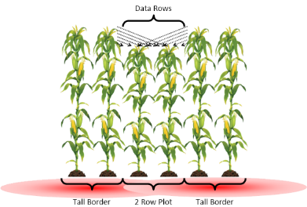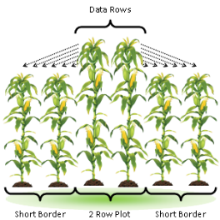
Figure 1. Figure that shows the potential competition effects on a 2-row plot with tall or short bordering plots. Competition can come from above via plant heights in bordering plants and from below via different underground effects. Plots can also receive a yield increase due to no competition for sunlight from bordering plots.

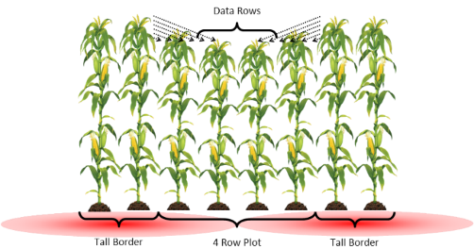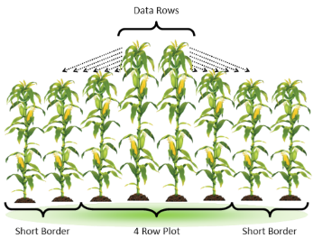
Figure 2. Figure that shows the potential competition effects on a 4-row plot with tall or short bordering plots. Competition can come from above via plant heights in bordering plants and from below via different underground effects. Plots can also receive a yield increase due to no competition for sunlight from bordering plots.
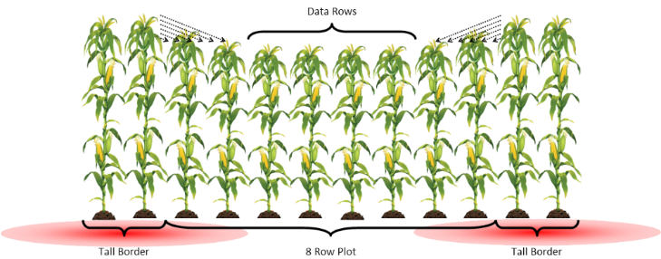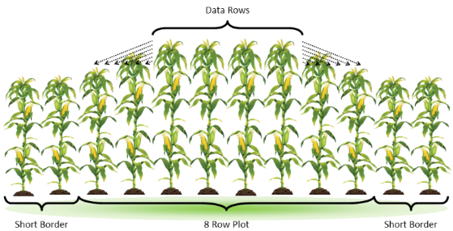
Figure 3. Figure that shows the potential competition effects on an 8-row plot with tall or short bordering plots. Competition can come from above via plant heights in bordering plants and from below via different underground effects. Plots can also receive a yield increase due to no competition for sunlight from bordering plots.

Materials and Methods

Germplasm
The germplasm selected were hybrids that fulfilled the needs for the experiment and have similar relative maturities (around 110 days for this experiment). The tall hybrid selected was 6127A3* due to it having a tall stature and 111-day relative maturity. The short hybrid selected was 6159SX* due to it having a medium-short stature and 111-day relative maturity. The two hybrids selected for 2-, 4-, and 8-row plots were 6049V2P* and 5909AM*. These two hybrids have a relative maturity of 110 and 109-days respectively and were both selected for their stability, agronomics, and medium stature plant height.

Experimental design
The hypothesis that is being tested here is that the plant height of a neighboring plot is a significant competitive factor in small plot research. The treatment design is constructed in a way that will evaluate different size plots with borders that have a significantly different plant height.
The experiment was designed to have three tests of differing sizes of experimental units (Figure 4). Treatments across all three tests are designed the same. It is a factorial design where 6049V2P and 5909AM are combined with three borders. The three borders are 6127A3 (tall), 6159SX (short), and the same hybrid (6049V2P or 5909AM) as a control. This makes six total treatments of two hybrids by three borders. The experimental design is the same for all three tests. They are all completely randomized designs with two replications of each treatment, except for the control. Due to size limitations, only one rep of the two control treatments were included for a total of 10 experimental units in each test.
The three test levels are 8-, 4-, and 2-rows. The 8-row test level experimental unit contains eight rows of either 6049V2P or 5909AM with two rows of either the short, tall, or control borders on both sides (Figure 4a) for a total of 12 rows. For each experimental unit, the middle four rows were harvested for data (Figure 3). The 4-row test level experimental unit is similar to the 8-row test level experimental unit, although it has four rows of 6049V2P or 5909AM per experimental unit (Figure 4b) for a total of 8 rows, and the middle two rows were harvested for data (Figure 2). The 2-row test level experimental unit is similar to the 8 and 4-row test level experimental units, although it has two rows of 6049V2P or 5909AM per experimental unit instead of eight or four (Figure 4c) for a total of six rows and both rows were harvested for data (Figure 1). The experiment was grown for one season at seven locations (Table 2).

 | a |  |  |  |  |  |  |  |  |  |  |  |  | b |  |  |  |  |  |  |  |  | c
 | T | T | A | A | A | A | A | A | A | A | T | T |  | S | S | B | B | B | B | S | S |  | A | A | A | A | A | A
 | B | B | B | B | B | B | B | B | B | B | B | B |  | T | T | A | A | A | A | T | T |  | S | S | B | B | S | S
 | S | S | B | B | B | B | B | B | B | B | S | S |  | T | T | B | B | B | B | T | T |  | S | S | A | A | S | S
 | S | S | A | A | A | A | A | A | A | A | S | S |  | B | B | B | B | B | B | B | B |  | T | T | B | B | T | T
 | T | T | B | B | B | B | B | B | B | B | T | T |  | S | S | B | B | B | B | S | S |  | T | T | A | A | T | T
 | S | S | A | A | A | A | A | A | A | A | S | S |  | T | T | A | A | A | A | T | T |  | S | S | A | A | S | S
 | S | S | B | B | B | B | B | B | B | B | S | S |  | A | A | A | A | A | A | A | A |  | T | T | B | B | T | T
 | T | T | B | B | B | B | B | B | B | B | T | T |  | S | S | A | A | A | A | S | S |  | S | S | B | B | S | S
 | T | T | A | A | A | A | A | A | A | A | T | T |  | T | T | B | B | B | B | T | T |  | T | T | A | A | T | T
 | A | A | A | A | A | A | A | A | A | A | A | A |  | S | S | A | A | A | A | S | S |  | B | B | B | B | B | B
Figure 4. An example of a field layout with randomization where a represents a block at the 8-row test level, b represents a block at the 4-row test level, and c represents a block as the 2-row test level. ‘A’ and ‘B’ represent the 2 hybrids, ‘T’ represents a tall hybrid, and ‘S’ represents a short hybrid. Each letter represents a single 20-foot row.

Data Collection
Each location was planted at seven yield trial testing locations in the Eastern corn belt. The planters used were Almaco SeedPro 360 8-row precision planters configured for test plots. All sites were planted into worked soil based upon the local best practices for each location. Planting dates were as representative of that location’s normal planting timeframe and based around the weather conditions of the year (Table 2).

Table 2. Planting dates for all planted locations.
Location (Abbreviations): | Planting dates:
Atlanta, IN (Clark) | 5/21/2021
Bluffton, IN (A-BU) | 5/17/2021
Champaign, IL (A-CP) | 5/14/2021
Elwood, IN (A-EL) | 5/15/2021
Lafayette, IN (A-LF) | 4/27/2021
Remington, IN (A-RM) | 5/24/2021
Terre Haute, IN (A-TH) | 5/14/2021

To measure the plant and ear heights, special poles were used in the field and notes were taken manually. The poles are 10 feet tall and have markings on them every four inches. This allows us to be accurate within approximately two inches. Each individual row was measured from the middle of the row to avoid any “alley effect” from having a gap between ranges. The ear heights were measured shortly following pollination. Ear height measurements were taken at the base of the ear. Plant heights were taken at the same time, by measuring heights in inches at the node of the flag leaf.
Harvest data were collected with a New Holland TR-88 combine that is retrofitted for research plots. Plots were harvested one row at a time. The plot weight, test weight, and moisture data were measured with a HarvestMaster H2 weighing system on the combine and then converted to bushels per acre. Only five of the seven locations were harvested due to two of the locations receiving poor weather during the growing season.

Data Analysis
The initial plan for analyzing the data was to look at each row individually and make inferences based upon the distance of each row from the border. At the 8-row test level, for each experimental unit, there would be eight rows of data. For 4- and 2-row test levels there would be four and two rows of data, respectively. Analysis of individual row data showed a large amount of row-to-row variability, and no consistent trends or statistical differences were detected. The next way of analyzing the data was to group the rows together in the same way they would be harvested in a typical experiment. The process consisted of grouping the harvest rows of each experimental unit together. The 8-row experimental unit would have the middle four rows grouped together as shown in Figure 3, the 4-row experimental unit would have the middle two rows grouped together as shown in Figure 2 and the 2-row experimental unit would have the two rows grouped together as shown in Figure 1. This grouping of rows both made the data more reliable and provided better data to make inferences on. This grouping also aligned the data better with the overall question of the experiment.
Three models were used to estimate the means of each treatment (Models 1, 2, and 3). Exploratory data analysis for this data was done with Model 1. Model 1 was used for each location and for each of hybrids 6049V2P and 5909AM. Model 2 pools all locations together and looks at each of the two hybrids 6049V2P and 5909AM. Most of the inferences were made with this model. A least square means table was produced with confidence intervals at 95%. All locations and hybrids were pooled together for Model 3 and an ANOVA table was produced. This ANOVA table was used to make inferences on what factors proved to be significant in this experiment. A fourth model (Model 4) was used to estimate plant heights for all hybrids in the experiment across all locations.

$Model 1: Trait= Test Level + Border +\left(Test Level x Border\right)+error$
$Model 2: Trait= Location + Test Level + Border+\left(Location x Test Level\right)+\left(Location x Border\right)+\left(Test Level x Border\right)+\left(Location x Test Level x Border\right)+error$
$Model 3: Trait= Location + Test Level + Border + Hybrid +\left(Location x Test Level\right)+\left(Location x Border\right)+\left(Location x Hybrid \right)+\left(Test Level x Border\right)+\left(Test Level x Hybrid\right)+ \left(Border x Hybrid\right)+\left(Location x Test Level x Border\right)+\left(Location x Test Level x Hybrid\right)+ \left(Location x Border x Hybrid\right)+\left(Test Level x Border x Hybrid\right) +\left(Location x Test Level x Border x Hybrid\right)+error$
$$Model 4: Trait= Location + Test Level + \left(Location x Test Level\right)$$

Results & Discussion

Results
Test level and its interactions with other factors were significant which means that the size of the test matters between 2, 4 or 8-rows (Table 3). Most of the variability within this experiment can be attributed to location, which is to be expected, but shows the importance of multi-environment trials in hybrid ranking studies. The border treatment was significant for yield, indicating that the heights of bordering plants can cause variability within an experiment and needs to be considered when designing a yield trial experiment.
Many observations can also be made from Table 4. First, location and hybrid are the most significant factors in this study regarding plant height. This is to be expected, but again shows the importance of multi-environment trials among hybrids. This also shows the importance of considering a larger test level, as hybrids can show great variability among plant heights. Second, less factors contribute as significantly for plant height as they would for yield. This shows that plant height is less responsive to borders and test level as yield is and that location and hybrid have a greater effect on plant height. Third, if the objective of an experiment is to measure plant height, this study shows increasing test level is not as impactful as it would be for yield, as test level alone shows no significance in the results for plant height.

Table 3. The sums of squares, mean squares, F-tests, and significant levels from the combined analysis of variance over five locations for grain yield based on Model 3.
Response: Yield
 | df | Sum of Squares | Mean Square | F | P
Location | 4 | 591008.17 | 147752.04 | 670.70 | 3.272E-151 | ***
Location:Test Level | 8 | 10739.26 | 1342.41 | 6.09 | 2.7012E-07 | ***
Test Level:Border | 4 | 7366.72 | 1841.68 | 8.36 | 2.0452E-06 | ***
Hybrid | 1 | 4689.51 | 4689.51 | 21.29 | 5.7931E-06 | ***
Location:Hybrid | 4 | 6817.77 | 1704.44 | 7.74 | 5.9214E-06 | ***
Test Level | 2 | 5327.97 | 2663.99 | 12.09 | 8.7691E-06 | ***
Location:Border | 8 | 8086.06 | 1010.76 | 4.59 | 2.6494E-05 | ***
Border | 2 | 4799.65 | 2399.83 | 10.89 | 2.6778E-05 | ***
Test Level:Hybrid | 2 | 2128.66 | 1064.33 | 4.83 | 0.00858594 | **
Location:Test Level:Border | 16 | 5709.30 | 356.83 | 1.62 | 0.06234319
Location:Border:Hybrid | 8 | 2994.82 | 374.35 | 1.70 | 0.09779801
Border:Hybrid | 2 | 655.37 | 327.69 | 1.49 | 0.22754855
Location:Test Level:Border:Hybrid | 16 | 2921.44 | 182.59 | 0.83 | 0.65244287
Location:Test Level:Hybrid | 8 | 1247.83 | 155.98 | 0.71 | 0.68443977
Test Level:Border:Hybrid | 4 | 201.73 | 50.43 | 0.23 | 0.92206179
Residuals | 310 | 68291.40 | 220.29
*,**, *** Significant at the 0.05, 0.01, 0.001 probability levels, respectively.

Table 4. The sums of squares, mean squares, F-tests, and significant levels from the combined analysis of variance over five locations for plant height based on Model 3
Response: Plant Height
 | df | Sum of Squares | Mean Square | F | P
Location | 4 | 9373.50 | 2343.37 | 455.31 | 2.231E-128 | ***
Hybrid | 1 | 2430.49 | 2430.49 | 472.24 | 2.8729E-64 | ***
Location:Test Level | 8 | 368.22 | 46.03 | 8.94 | 4.8634E-11 | ***
Location:Test Level:Border:Hybrid | 16 | 375.44 | 23.47 | 4.56 | 3.3838E-08 | ***
Location:Hybrid | 4 | 103.66 | 25.92 | 5.04 | 0.00060542 | ***
Test Level:Border | 4 | 93.72 | 23.43 | 4.55 | 0.00138005 | **
Test Level:Border:Hybrid | 4 | 69.36 | 17.34 | 3.37 | 0.01018711 | *
Location:Border | 8 | 95.30 | 11.91 | 2.31 | 0.02007781 | *
Location:Test Level:Hybrid | 8 | 72.86 | 9.11 | 1.77 | 0.08239762
Border | 2 | 25.45 | 12.72 | 2.47 | 0.08604278
Test Level:Hybrid | 2 | 24.09 | 12.04 | 2.34 | 0.09799793
Border:Hybrid | 2 | 17.61 | 8.81 | 1.71 | 0.18242648
Location:Border:Hybrid | 8 | 39.24 | 4.91 | 0.95 | 0.47302511
Location:Test Level:Border | 16 | 80.98 | 5.06 | 0.98 | 0.47470251
Test Level | 2 | 0.33 | 0.17 | 0.03 | 0.96845273
Residuals | 310 | 1595.50 | 5.15
*,**, *** Significant at the 0.05, 0.01, 0.001 probability levels, respectively.

Table 5 shows the numerical data with least square means, standard error, and confidence levels at 95% confidence for yield. For both hybrids, all 8-row border treatments showed no difference between treatments within the respective hybrids. As the test level decreases, there are more differences between treatments. The largest difference across test levels can be found with the tall border treatment. The 2-row test level tall border treatment shows no similarities to the 4 or 8-row test levels for any other treatments within each hybrid. This aligns with the general trend that the tall border shows to have the most effect on the yield. This data can also show that within 8-row test levels, hybrid performance shows the most accurate estimations as all three pairwise comparisons show to be the same for both hybrids. Within the 4-row test level, this accuracy drops as only one and two of the pairwise comparisons show to be the same for 6049V2P and 5909AM respectively. Within the 2-row test level, accuracy drops even further as 6049V2P only has one pairwise comparison to be the same while 5909AM does not have any pairwise comparisons that are the same (Table 6).

Table 5. Table with numerical data for least square means, standard error, and upper and lower confident levels at 95% confidence in relation to Model 2 for grain yield in bushels per acre. This table shows the 2, 4, and 8 row data with each border treatment for hybrids 6049V2P and 5909AM.
 |  | Yield (bu/ac)
 | Hybrid | 6049V2P
 | Test Level | 2 |  |  |  | 4 |  |  |  | 8
 |  | Mean | SE | CL_{.95} |  | Mean | SE | CL_{.95} |  | Mean | SE | CL_{.95}
Border | Control | 258 | 4.81 | 249 - 268 |  | 261 | 4.81 | 252 - 271 |  | 259 | 3.40 | 253 - 266
Border | Short | 264 | 3.40 | 257 - 271 |  | 259 | 3.40 | 252 - 266 |  | 255 | 2.41 | 250 - 260
Border | Tall | 242 | 3.40 | 235 - 248 |  | 251 | 3.40 | 244 - 257 |  | 259 | 2.41 | 254 - 263
 | Hybrid | 5909AM
 | Test Level | 2 |  |  |  | 4 |  |  |  | 8
 |  | Mean | SE | CL_{.95} |  | Mean | SE | CL_{.95} |  | Mean | SE | CL_{.95}
Border | Control | 240 | 4.57 | 231 - 249 |  | 247 | 4.57 | 238 - 256 |  | 254 | 3.23 | 248 - 260
Border | Short | 251 | 3.23 | 245 - 257 |  | 254 | 3.23 | 248 - 261 |  | 255 | 2.29 | 251 - 260
Border | Tall | 228 | 3.23 | 222 - 235 |  | 244 | 3.23 | 238 - 250 |  | 253 | 2.29 | 249 - 258

Table 6. Table showing the difference between yield least square means in bushels per acre (LSM above – LSM left). Values in bold represent values that are significantly different at 95% confidence.
Yield (bu/ac)
6049V2P
Test Level |  | 2 |  |  | 4 |  |  | 8
 | Border | C | S | T | C | S | T | C | S | T
2 | C | 0 | 5.9 | -16.5 | 3.1 | 0.8 | -7.5 | 1.4 | -3.3 | 0.4
2 | S |  | 0 | -22.4 | -2.8 | -5.1 | -13.4 | -4.6 | -9.3 | -5.5
2 | T |  |  | 0 | 19.6 | 17.3 | 9.0 | 17.8 | 13.1 | 16.8
4 | C |  |  |  | 0 | -2.3 | -10.6 | -1.8 | -6.5 | -2.8
4 | S |  |  |  |  | 0 | -8.3 | 0.5 | -4.2 | -0.5
4 | T |  |  |  |  |  | 0 | 8.8 | 4.1 | 7.8
8 | C |  |  |  |  |  |  | 0 | -4.7 | -1.0
8 | S |  |  |  |  |  |  |  | 0 | 3.7
8 | T |  |  |  |  |  |  |  |  | 0
5909AM
Test Level |  | 2 |  |  | 4 |  |  | 8
 | Border | C | S | T | C | S | T | C | S | T
2 | C | 0 | 11.1 | -11.7 | 6.9 | 14.5 | 4.1 | 14.1 | 15.5 | 13.3
2 | S |  | 0 | -22.7 | -4.2 | 3.4 | -7.0 | 3.0 | 4.4 | 2.3
2 | T |  |  | 0 | 18.5 | 26.1 | 15.8 | 25.8 | 27.1 | 25.0
4 | C |  |  |  | 0 | 7.6 | -2.8 | 7.2 | 8.6 | 6.5
4 | S |  |  |  |  | 0 | -10.4 | -0.4 | 1.0 | -1.1
4 | T |  |  |  |  |  | 0 | 10.0 | 11.4 | 9.2
8 | C |  |  |  |  |  |  | 0 | 1.4 | -0.8
8 | S |  |  |  |  |  |  |  | 0 | -2.1
8 | T |  |  |  |  |  |  |  |  | 0

When comparing the ranking between the two hybrids Table 7 shows that rankings are heavily influenced by border. 6049V2P would be considered the superior hybrid between the two in most cases, although when matched with a tall border, it is more likely to be beat by 5909AM. Another thing to note is that when test level increases, the difference between the hybrids decreases. This can be due to hybrids performing differently in plots versus in pure stands because of various competition effects. One could infer here that 5909AM struggles in small plots or that 6049V2P excels in small plots where in pure stands they are much more similar to each other.

Table 7. Table showing the difference between hybrids for grain yield in bushels per acre where each value represents the difference between 6049V2P and 5909AM. The values in bold represent values where 5909AM yielded greater than 6049V2P.
Yield (bu/ac)
 |  |  | 6049V2P
 | Test Level |  | 2 |  |  | 4 |  |  | 8
 |  | Border | C | S | T | C | S | T | C | S | T
5909AM | 2 | C | 18.2 | 24.1 | 1.7
5909AM | 2 | S | 7.1 | 13.0 | -9.3
5909AM | 2 | T | 29.8 | 35.7 | 13.4
5909AM | 4 | C |  |  |  | 14.5 | 12.1 | 3.9
5909AM | 4 | S |  |  |  | 6.8 | 4.5 | -3.8
5909AM | 4 | T |  |  |  | 17.2 | 14.9 | 6.6
5909AM | 8 | C |  |  |  |  |  |  | 5.4 | 0.7 | 4.5
5909AM | 8 | S |  |  |  |  |  |  | 4.1 | -0.6 | 3.1
5909AM | 8 | T |  |  |  |  |  |  | 6.2 | 1.5 | 5.2

The data in Figure 5 show the least square means for yield using Model 2 with upper and lower confidence intervals. Four observations can be made here. First, the tall border treatment shows a consistent relationship with test level, whereas test level increases, the yield also increases. This treatment shows the most response of border heights. Second, the spread between yield tightens as test level increases. This shows that as harvested rows have more buffer between the border, there is more consistency in the yield estimation between treatments. Third, the short and control border treatments look to show less response than the tall border treatment. Fourth, Figure 5 shows that the upper and lower confidence levels merge towards the mean within treatments as test level increases. This is a result of having more rows attributing towards the estimation but shows that more confident evaluations can be made in greater plot sizes.
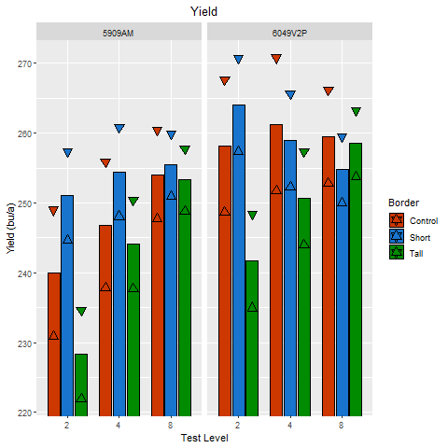
Figure 5. The grain yield least square means in bushels per acre relating to Model 2 for all locations combined. Each bar represents the least square means, the triangles represent the upper and lower confidence interactions as 95%.

A similar approach can be taken with plant heights in Tables 8 and 9. The 8-row test level shows some unexpected results for 6049V2P as only one of the pairwise combinations show similar plant heights, whereas 5909AM shows all three pairwise combinations show similar plant heights. For 6049V2P however, the 4- and 2-row test levels show a similar trend with yield, as three combinations are the same for the 4-row test and less for the 2-row test, two combinations. The same is true with 5909AM where three combinations are the same for the 4-row test and no combinations for the 2-row test level are the same.

Table 8. Table with numerical data for least square means, standard error, and upper and lower confident levels at 95% confidence in relation to Model 2 for plant height in inches. This table shows the 2, 4, and 8 row data with each border treatment for hybrids 6049V2P and 5909AM.
 |  | Plant Height (in)
 | Hybrid | 6049V2P
 | Test Level | 2 |  |  |  | 4 |  |  |  | 8
 |  | Mean | SE | CL_{.95} |  | Mean | SE | CL_{.95} |  | Mean | SE | CL_{.95}
Border | Control | 98 | 0.70 | 96.6 - 99.4 |  | 97.2 | 0.70 | 95.8 - 98.6 |  | 97.4 | 0.49 | 96.4 - 98.4
Border | Short | 97.2 | 0.49 | 96.2 - 98.2 |  | 98.3 | 0.49 | 97.3 - 99.3 |  | 99.6 | 0.35 | 98.9 - 100.2
Border | Tall | 99.2 | 0.49 | 98.2 - 100.2 |  | 98.3 | 0.49 | 97.3 - 99.3 |  | 98.2 | 0.35 | 97.5 - 98.8
 | Hybrid | 5909AM
 | Test Level | 2 |  |  |  | 4 |  |  |  | 8
 |  | Mean | SE | CL_{.95} |  | Mean | SE | CL_{.95} |  | Mean | SE | CL_{.95}
Border | Control | 91.6 | 0.74 | 90.1 - 93.1 |  | 94.2 | 0.74 | 92.7 - 95.7 |  | 93.6 | 0.52 | 92.6 - 94.6
Border | Short | 93.6 | 0.52 | 92.6 - 94.6 |  | 93.2 | 0.52 | 92.2 - 94.2 |  | 93.2 | 0.37 | 92.4 - 93.9
Border | Tall | 94.8 | 0.52 | 93.8 - 95.8 |  | 93.9 | 0.52 | 92.9 - 94.9 |  | 92.9 | 0.37 | 92.2 - 93.6

Table 9. Table showing the difference between plant height least square means in inches (LSM above – LSM left). Cells in bold represent values that are significantly different at 95% confidence.
Plant Height (in)
6049V2P
Test Level |  | 2 |  |  | 4 |  |  | 8
 | Border | C | S | T | C | S | T | C | S | T
2 | C | 0 | -0.8 | 1.2 | -0.8 | 0.3 | 0.3 | -0.6 | 1.6 | 0.2
2 | S |  | 0 | 2 | 0 | 1.1 | 1.1 | 0.2 | 2.4 | 1
2 | T |  |  | 0 | -2 | -0.9 | -0.9 | -1.8 | 0.4 | -1.1
4 | C |  |  |  | 0 | 1.1 | 1.1 | 0.2 | 2.4 | 1
4 | S |  |  |  |  | 0 | 0 | -0.9 | 1.3 | -0.2
4 | T |  |  |  |  |  | 0 | -0.9 | 1.3 | -0.2
8 | C |  |  |  |  |  |  | 0 | 2.2 | 0.8
8 | S |  |  |  |  |  |  |  | 0 | -1.4
8 | T |  |  |  |  |  |  |  |  | 0
5909AM
Test Level |  | 2 |  |  | 4 |  |  | 8
 | Border | C | S | T | C | S | T | C | S | T
2 | C | 0 | 2 | 3.2 | 2.6 | 1.6 | 2.3 | 2 | 1.6 | 1.3
2 | S |  | 0 | 1.2 | 0.6 | -0.4 | 0.3 | 0 | -0.5 | -0.7
2 | T |  |  | 0 | -0.6 | -1.6 | -0.9 | -1.2 | -1.7 | -1.9
4 | C |  |  |  | 0 | -1 | -0.3 | -0.6 | -1.1 | -1.3
4 | S |  |  |  |  | 0 | 0.7 | 0.4 | -0.1 | -0.3
4 | T |  |  |  |  |  | 0 | -0.3 | -0.8 | -1
8 | C |  |  |  |  |  |  | 0 | -0.5 | -0.7
8 | S |  |  |  |  |  |  |  | 0 | -0.3
8 | T |  |  |  |  |  |  |  |  | 0

The data in Figure 6 shows the least square means for plant height using Model 2 with the upper and lower limits at 95% confidence. Four observations can be made here similar to the yield analysis. First, the tall border treatment shows a consistent inverse relationship with test level, whereas test level increases, the plant height decreases. This treatment shows the most response of border heights as well. Second, the spread between plant height tightens as test level increases. This shows that as harvested rows have more buffer between the border, there is more consistency in the plant height estimation between treatments. Third, the short and control border treatments look to show less response than the tall border treatment. Fourth, the upper and lower confidence levels merge towards the mean within treatments as test level increases. This is because there are more rows attributing to the estimations and shows that a more confident estimation can be made as plot sizes increase.

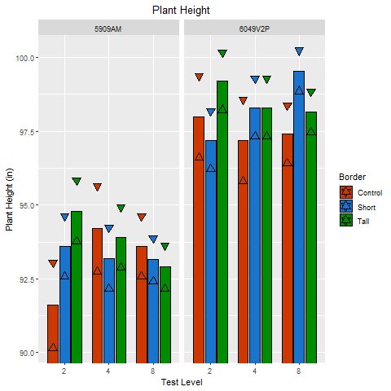
Figure 6. The plant height least square means in inches relating to Model 2 for all locations combined. Each bar represents the least square means, the triangles represent the upper and lower confidence interactions as 95%.

The data from Model 2 shows that there is more accuracy in evaluating hybrid performance at an 8-row test level and that accuracy decreases at test level also decreases. In an experiment where hybrids show a wider range of plant heights, the 8-row test is going to be the most optimal way to rank hybrids of the three test sizes studied here.
The data shown in Figure 7 represents the yield least square means from Model 1. Three observations are important in this figure. First, the tall border treatment shows a general trend to increase yield as the test level increases. Second, the spread of yield estimates generally tightens as the test level increases. Third, the short and control border treatments show more irregular patterns across test levels.
The data in Figure 8 represents the least square means plant heights from Model 1. Three more observations are important in this figure. First, the tall border treatment generally shows an inverse trend to the yield estimations. As test level increases, the plant height often decreases. Second, the spread of plant height estimates also generally tightens as the test level increases. Third, the short and control border treatments show more irregular patterns across test levels.
The third observation for both figures can likely be explained because of two reasons. First, the short hybrid selected actually showed a response to the plants around it and grew taller than that hybrid does in a pure stand. Second, the control border treatment only has one replication, so an estimate on the control was less confident.

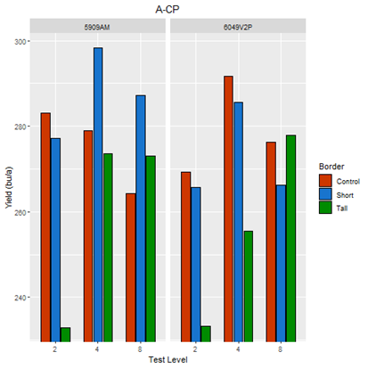 | 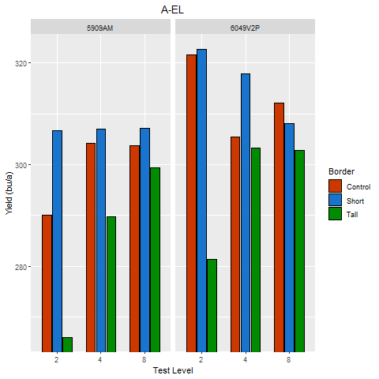
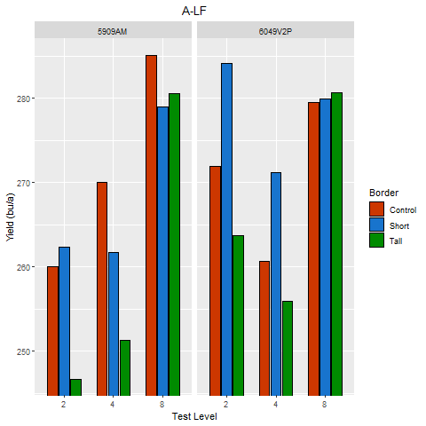 | 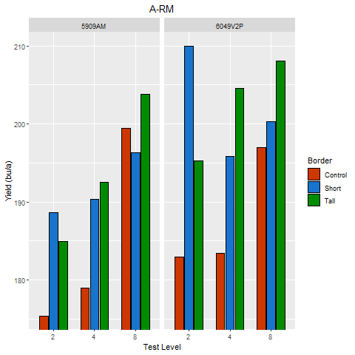
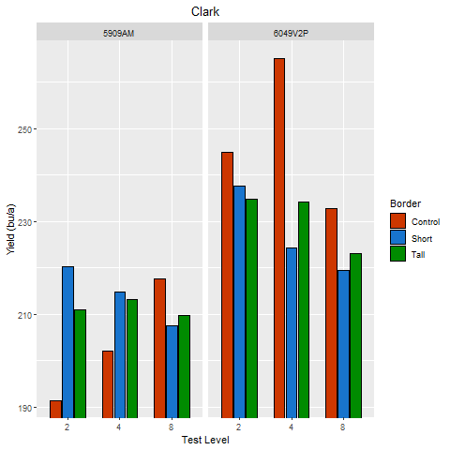
Figure 7. The least square means in bushels per acre relating to Model 1 for each of the five locations that contained acceptable data. Each graph shows the least square mean yield for each variety within each test level and bordered by each border.
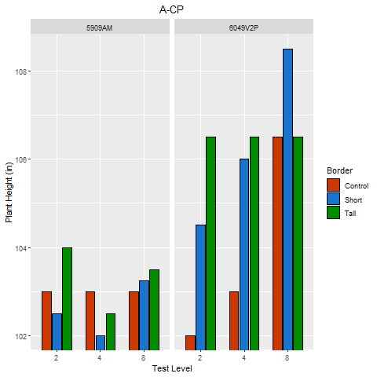 | 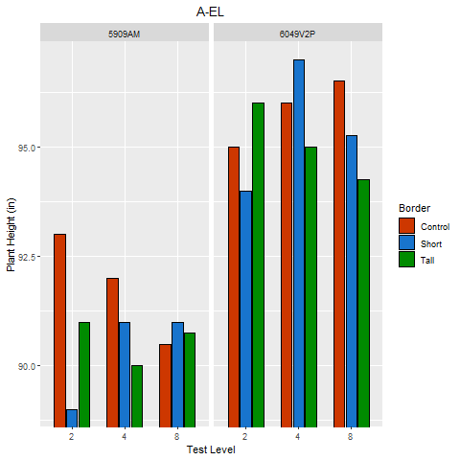
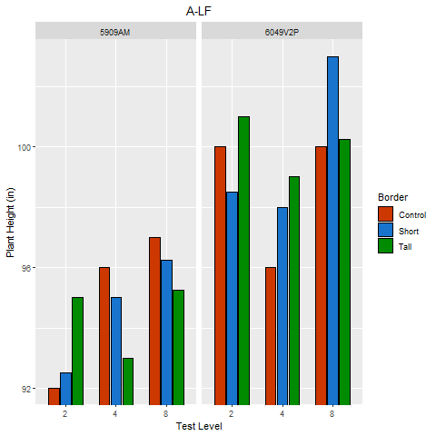 | 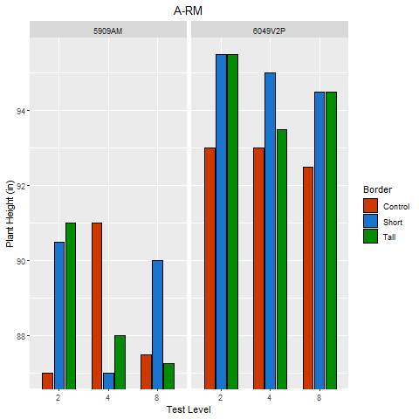
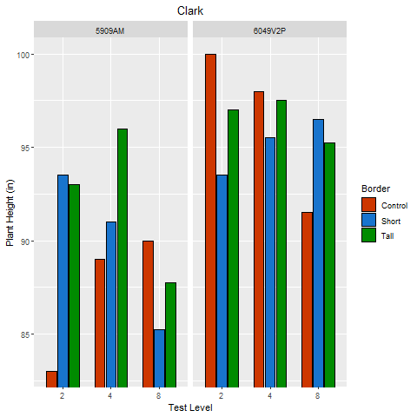
Figure 8. The least square means in inches relating to Model 2 for each of the five locations that contained acceptable data. Each graph shows the least square mean plant height for each variety within each test level and bordered by each border.
It’s important to note the plant heights for each of the hybrids used in this experiment. Figure 9 shows least square means plant heights from Model 4 for each of the three test levels. 6127A3 performed as expected for the tall hybrid. It was at least 12 inches taller than 6049V2P and 16 inches taller than 5909AM. 6159SX however, did not perform as a short hybrid as expected for a short border, especially in combination with 5909AM. Only in the 4-row test level was this hybrid shorter than the 5909AM. It was however shorter than 6049V2P although only by around four inches.

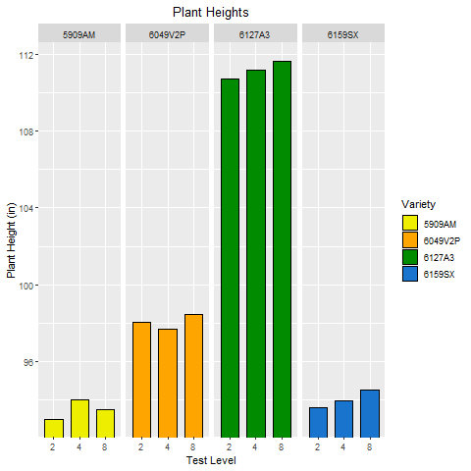
Figure 9. Figure showing the least square means plant heights in inches for each of the hybrids used in this experiment based on Model 4.

Recommendations and summary
Overall, this study shows that there are significant differences between 2, 4 and 8-row test levels when considering grain yield for a corn hybrid in an experiment where hybrids show different plant heights. This difference can be attributed to the size of the plants bordering a plot, and the width of the plot. In an experiment where hybrids are going to have a wide range of plant heights, the optimal plot width of these three is going to be eight rows, harvesting the middle four rows. This plot width is going to give the most accurate yield evaluation with greatest confidence. This study also further shows that plant height is much more fixed in a hybrid than grain yield. Even though there were significant differences between treatments, the range of differences is almost negligible in consideration with ordinary corn plant heights.
Where half-sibs and full-sibs are grouped together, 2-row plots will likely suffice for yield estimations because height differences aren’t to be expected. This also correlates with C and B level experiments where the most hybrids are evaluated. As the relationship between hybrids decreases in A, pre-commercial, and commercial level experiments, 4-row and 8-row plots are going to become necessary for proper evaluation.
There are trade-offs to increasing plot sizes, mainly with resource allocation. With 8-row plots less hybrids, or reps of hybrids, may be evaluated within a given budget. Where multiple reps are already allocated of a smaller plot size, 8-row plots may be considered as a replacement for reps. There isn’t enough information in this study to suggest that a 4-row, 40-foot plot should be substituted for an 8-row, 20-foot plot. Further experiments should be done to explore plot lengths with regards to alley widths and bordering plant competition effects to find an optimal plot length.
Going forward with this study, two recommendations could be made. First, the hybrid selected for the short border did not perform as expected as it grew taller than normal in a pure stand. A short hybrid that is more consistently short should be used. Second, looking at Tables 3 and 4, hybrid shows a great significance to the results of the study. Only two hybrids were used in this study where more hybrids should be used going forward. This could give more insight on the interactions between hybrid and the other factors in the study. This will also allow analysis of hybrid ranking to determine if hybrids rank the same in different sizes of test plots.

References

References
Castleberry, R.M. 1986. “Border Heights Effects on Two Row Corn Plot Yields”. Proceedings of the Forty-First Annual Corn & Sorghum Industry Research Conference 1986 41:171-179.
Genter, C.F. 1958. “Plot Competition Between Corn Hybrids”. Journal of the American Society of Agronomy 50:205-206. https://doi.org/10.2134/agronj1958.00021962005000040010x
Kiesselbach, T.A. 1923. “Competition as a Source of Error in Comparative Corn Yields”. Journal of the American Society of Agronomy 15:199-215. https://doi.org/10.2134/agronj1923.00021962001500050005x

Legal Statement
* Please refer to beckshybrids.com/technology-legal.pdf for licensing and trademark information

