Automated sorting of haploids in maize

by

MARIAH K. MITCHELL

A creative component submitted to the graduate faculty

in partial fulfillment of the requirements for the degree of

MASTER OF SCIENCE

Major: Seed Technology and Business

Program of Study Committee:
Dr. Thomas Lubberstedt, Major Professor
Dr. Ursula K. Frei
Dr. A. Susana Goggi
Dr. Haozhe Chen

Iowa State University

Ames, Iowa

May 2023
Copyright © Mariah K. Mitchell, 2023. All rights reserved
DEDICATION
To Honor my Savior Jesus and Aaron Boysen
It is without a doubt that I have not gotten this far on my own. Every opportunity that I’ve come across, every person that I’ve met, every school that I’ve attended, and every job that I’ve had, has been by design. Every accomplishment is not my own, but Yours.
A part of my love for agriculture derived from one person, Aaron Boysen. I hope to share my knowledge so passionately that others fall in love with agriculture, too. I have never been so grateful for a single conversation and the opportunity to have known you.
TABLE OF CONTENTS
Page
LIST OF FIGURES v
LIST OF TABLES vi
NOMENCLATURE vii
ACKNOWLEDGMENTS viii
ABSTRACT ………………………………. x
CHAPTER 1 INTRODUCTION: DOUBLED HAPLOID BREEDING IN
MAIZE …………... 1
Economic impact of DHs 1
DH process 2
The technology 3
Anthocyanin marker 4
The QualySense Qsorter® Explorer 6
Functions 6
Use for haploid sorting 7
Identifying kernels by physical characteristics 7

CHAPTER 2 MATERIALS AND METHODS 9
Material 9
Methods 10
Sorting thresholds 10
Data acquisition 13

CHAPTER 3 RESULTS 15
Haploid sorting purity 15
First Run: Bin 3 15
Second run: Bin 3 16
Haploid sorting recovery 17
True Positive 18
False Positive 20
False Negative 21
Comparing inducer lines 22

CHAPTER 4 DISCUSSION 25
Market Groups 25
Economics 26
The future of the QSE 28
The future of automated sorting 29

REFERENCES 31
APPENDIX 33
LIST OF FIGURES

Page

Figure 1 Haploid induction and DH line production 3

Figure 2 Haploid identification based on the R1-nj genetic marker 6

Figure 3 The QualySense Qsorter® Explorer 7

Figure 4 The experiment sorting process 10

Figure 5 Figure 5 An example of the QSE’s experimental panel for adjusting Bin 3’s thresholds 11

Figure 6 Graph of Run 1: Bin 3 kernel distribution 15
Figure 7 Graph of Run 2: Bin 3 kernel distribution 17
Figure 8 Graph of haploids recovered in sort 1, 2, and overall 19
Figure 9 Graph of the relationship between FPR and HR 20
Figure 12 Comparing haploids and diploids from 6 batches 23-24
LIST OF TABLES

Page
Table 1 Threshold effects on haploid purity and recovery 13
Table 2 Run 1 results 15
Table 3 Run 2 results 17

Table 4 Haploid recovery summary table 18
Table 5 False positive summary table 21

Table 6 False negative summary table 22

Table 7 (a-d) Estimated costs of programs with and without using the QSE for haploid sorting 28

NOMENCLATURE

DH Doubled Haploid
NIR Near-Infrared Spectrometry
NMR Nuclear Magnetic Resonance
QSE QualySense Qsorter® Explorer
TP True Positive
FP False Positive
TN True Negative
FN False Negative
HR Haploid Recovery

FNR False Negative Rate

FPR False Positive Rate

FDR False Discovery Rate
ACKNOWLEDGMENTS

I am forever indebted to the people in my life who have dedicated their time and resources to getting me to where I am today. This project is only successful because of these individuals. I am completely honored to have collaborated with people who have impacted this industry tremendously.
I seriously cannot thank my major professor, Dr. Thomas Lubberstedt, and my committee members, Dr. Ursula Frei, Dr. A. Susana Goggi, and Dr. Haozhe Chen enough. Specifically, Dr. Lubberstedt and Dr. Frei, for their guidance and support throughout the course of this research. You took time out of your busy schedules to have discussions, conduct research, and share your abundance of knowledge with me. The hours you have spent helping me have not gone unappreciated.
Thank you to Lori Youngberg for allowing me to be so successful in the Seed Technology and Business program. You were a resource and a source of confidence during my time at Iowa State University.
If not for Todd Piper, I would not have a subject for this creative component. Thank you for sharing your knowledge of doubled haploids and having the confidence to grant me independence while working with the QualySense Qsorter. Through you, I met individuals who were crucial to the success of this component.
Thank you to my parents, Troy and Robyn. You have supported me endlessly through every phase of my life. Your love is limitless and I cannot acknowledge how far I’ve come without acknowledging where I’ve come from.
Finally, to my fiancé Koby. Thank you for sharing my passion for agriculture, you are my biggest supporter. But most importantly, thank you for researching how to recover the ten pages of this component I didn’t save.

ABSTRACT

With the growing need to produce high-yielding cultivars more rapidly than ever, breeders are forced to shorten their prolonged breeding programs. Doubled haploid breeding is a sure way to relieve the time constraints of commercialization by rapidly developing fully homozygous inbred lines in just two generations. The creation of doubled haploids consists of four general steps: (1) induction of female lines, (2) identification of haploids, (3) doubling of the haploid genome, and (4) self-pollination of doubled haploids. Haploid identification takes a lot of time and money to perform since present-day induced fields contain a lot of unwanted diploids, rather than the desired haploid kernels. Automated sorting holds great potential to further increase accuracy and effectiveness, and decrease major constraints such as labor, cost, and time. This creative component reviews the results of haploid sorting, including its sorting accuracy, and statistically shows the benefits of running a batch of seed twice through the QualySense Qsorter® Explorer. Large breeding groups that harvest large quantities of seed from induced fields will find automated haploid sorting a better option over manual sorting, rather than small breeding programs that may not find economic value. Automated sorting’s economic importance, functions, effectiveness, limitations, and niche markets are highlighted throughout the creative component. Together, with the future of doubled haploid advances, the full potential of automated sorting and DH technology will be realized.

CHAPTER I
INTRODUCTION: DOUBLED HAPLOID TECHNOLOGY IN MAIZE
The value of doubled haploid (DH) technology has been vastly recognized in maize breeding programs globally, having a great impact on decreasing breeding time, resources, labor, and cost (Weber et al., 2013). This form of developing homozygous inbred lines is considerably faster than traditional breeding methods. Inbreeding in maize would previously consist of self-pollinating a line six to eight times to ensure almost perfect homozygosity. Despite these seasons of selfing, 100% genetically inbred maize was often not the result. Through DH breeding methods, completely homozygous lines can be created in just two seasons.
Economic impact
DH lines are expected to be 26% cheaper to produce and overall have a larger economic impact than conventional inbred lines (Rajcan et al., 2011). Advantages of DH breeding methods include improving genetic gain by shortening the normal inbred development time, ease of adoption to breeding programs due to there being no need for specialized labs, correlating with cost efficiency and lower labor requirements, providing great lines for marker technology and mapping due to complete homozygosity, and easier implementation of biotech genes (Weber et al., 2013). Some other advantages of DH technology can include the development of improved parents and hybrids, and increased genetic gain (Rajcan et al., 2011).
Breeders are continuously pressed to deliver lines integrated with new traits and improved yield, more rapidly than ever. Especially, as the human population around the globe increases (Vanous et al., 2017). DHs are valuable in considering G x E (Genotype x Environment) interactions regarding them having no residual heterozygosity (Chaikam, 2019). As DH technology grows, breeders will save time and money while developing higher-performing cultivars. Positively, public and private breeding programs have continued to capitalize on DH technology in quickly developing inbred lines and relating hybrids (Rajcan et al., 2011).
DH process
The in vivo process of doubled haploid production consists of four general steps: (1) induction of female lines, (2) identification of haploids, (3) doubling of haploid genome, (4) self-pollination of doubled haploids (Dermail, 2023). The projected result is maize plants that represent the genetic variability of the female (donor) plant. At the start of DH development (after the creation of the desired female donor), the female plant will be pollinated by a male referred to as the “inducer”. The inducer is a maize plant that contains a genetic mutation resulting in abnormalities during double fertilization. The assumption is that male chromosomes are lost during the first cell division of the egg cell. There are many ideas of how this truly happens, but the exact mechanism is unknown. Despite the unknown, the results are kernels containing only one set of maternal chromosomes, supported by a regular triploid endosperm. Because no inducer/male genes remain in the female plant after pollination, the created haploid plant only contains the desired female traits. Haploid induction occurs at about 10-15%, indicating that up to 75 haploids could be obtained from roughly 500 seeds of typical F₁ or F₂ donor ears (Dermail, 2023). As most of the seeds produced by pollination with an inducer are just normal hybrids between the donor female and inducer male, successfully induced kernels need to be sorted and separated from diploid kernels that were either unsuccessfully induced or pollinated by an adventitious male. Haploid kernels either undergo spontaneous or induced genome doubling by exposing haploids to a doubling agent or mitotic inhibitor, commonly colchicine (Liu et al., 2016) (Vanous et al., 2017). Diploid offspring with two identical genomes (2n) is the result. All tissue will not be doubled, but rather ideally the flowering tissues (Vanous et al., 2017). A ny haploid plant where both the male and female flowering tissues underwent chromosome doubling will have restored fertility and can be maintained by self-pollination. The kernels on the resulting ear are completely homozygous doubled haploid line.
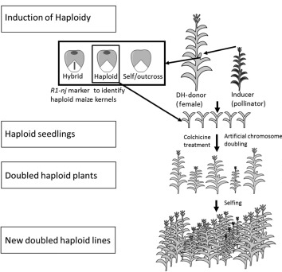
Figure 1 Haploid induction and DH line production
https://www.quora.com/What-is-the-definition-of-a-double-haploid-in-plants
The technology
DH technology is a sure way to shorten the time from early hybrid development to commercialization. Vast improvements have been made in these three areas, causing DH technology to flourish: (1) the development of high-performing haploid-inducing lines, (2) the use and creation of genetic markers for haploid identification, (3) the development of effective and efficient chromosome-doubling methods (Weber et al., 2013). “Since inducers still produce a relatively small portion of haploids among undesirable diploid kernels, haploid identification through classical techniques like stomatal size and density, chromosome counting, and flow cytometry is accurate but laborious, costly, and time-consuming” (Dermail, 2023). Although induction rates in maize have improved from 0.1% to over 10% (Singh et al., 2021), DH breeding presents a need for a sorting method that is both cost-effective and efficient regarding time, labor, and sorting accuracy. There are many discovered methods of separating haploids and diploids, which can be done at various maize growth stages. The seedling stage can be evaluated for coleoptile length, radical length, and the number of lateral seminar roots since there is a significant difference from diploids (Qu, 2021). Cytogenetic and molecular markers can determine ploidy level including looking at chloroplast and stomatal guard cell properties, chromosome counting, flow cytometry, and DNA markers (Dermail, 2023). Morphological differences can be evaluated; haploids have narrow and upright leaves, with lower plant height and ear position than diploid plants (Qu, 2021). Ultimately, these methods are costly and laborious due to the need for a greenhouse or field space. Kernels have also been sorted by analyzing compositional components like oil content using near-infrared spectrometry (NIR) or nuclear magnetic resonance (NMR). Despite their efficiency, sorting by oil content often requires manual sorting afterward because embryo aborted kernels and haploid kernels have similar oil content (Qu, 2021). Arguably the most common method of haploid identification, and the focus of this study, is the visual sorting of haploids. Visual sorting can be accomplished both manually and automatically.

Anthocyanin marker
To help facilitate haploid visual sorting, an endosperm and embryo genetic marker has been introduced to inducer lines. R1-navajo (nj), is a transcription factor in the anthocyanin pathway. In the presence of the R1-nj allele, both the embryo and the aleurone of the kernel show purple pigmentation. The use of the R1-nj marker has paved the way for breeding programs during the past decade (Melchinger et al., 2013). To understand how the color gene is expressed within the kernel, we must know that maize is double-fertilized. This means, both the embryo and the endosperm receive a sperm cell from the pollen that lands on maize silks. Because of this, we can ideally identify aleurones and embryos that were pollinated by the inducer by the presentation of the purple gene. An example of kernels that were successfully and non-successfully pollinated by the male inducer is in Figure 2. The haploid seed will have a colorless embryo and a purple aleurone. A diploid kernel, one whose inducer chromosomes were not successfully deleted, will have both a purple embryo and aleurone. No coloration in either the embryo or the cap of the endosperm indicates outcrossing contamination. Visual sorting by hand is subject to human biases and high labor intensity. Modern imaging techniques and automated sorting create a faster, more effective, haploid recovery process (Singh et al., 2021). Within this study, it’s important to note that the expression of the R1, nj color marker depended vastly on environmental conditions and genetic backgrounds (Singh et al., 2021). Despite this, the purple marker has been extensively used in maize for DH production (Singh et al., 2021).

A B C

Figure 2 Haploid identification based on the R1-nj genetic marker a. Haploid kernels b. Diploid kernels c. Outcross kernels

The QualySense Qsorter® Explorer

The QualySense Qsorter® Explorer (QSE) is an advanced robot that performs single kernel sorting and analysis using artificial intelligence and advanced mechatronics. QualySense advertises this automated machine as one of the most advanced platforms for haploid sorting. The QSE uses a 2D/3D camera and a high-resolution near-infrared spectrometer to sort each kernel and produce its reports. In and outside of its use in the haploid breeding process, the sorting machine can be used as a non-destructive way to select seeds concerning several compositional and physical parameters. Working with any commodity, maize, soybeans, sunflower, wheat, or more, the Qsorter® provides the user a deeper understanding of key breeding parameters, the ability to run complex sorting experiments in a multitude, create populations that are larger and targeted, and have a higher chance of success in running field trials (QSorter® Explorer).
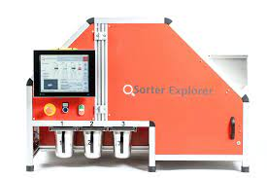
Figure 3 The QualySense Qsorter® Explorer
Functions
The QSE can inspect both physical (e.g., size, shape, color, defects) and biochemical (e.g., protein, moisture, oil, sucrose) characteristics for analysis in one pass (QSorter® Explorer). Once a batch is placed in the hopper, the unit can (1) sort out the defective kernels, (2) measure the batches for oil, moisture, protein, and other compositional components, (3) analyze additional characteristics as in size, weight and (4) report all of the parameters in a digital report to be defined and shared by stakeholders (QSorter® Explorer). These analyses can be performed on several crops like coffee beans, maize, soybeans, rice, oats, peanuts, hemp, and barley (Seeds & Grains).
Use for Haploid Sorting
Although there are many niche consumers for the QSE, the use of the machine for doubled haploid breeding has become increasingly popular. One can use the device to sort haploids and diploids in multiple ways. Analyzing compositional components, as in oil content, can be achieved using the sorter’s near-infrared spectrometer. Potentially more common is sorting the kernels using the 2D/3D camera, looking specifically for the presence of a purple embryo. Ultimately, the goal of sorting is to find kernels that present no color in their embryo and contain purple in their endosperm. The QSE uses multispectral imaging to look at the embryos of about 30 kernels per second, separating those with purple embryos from those with colorless embryos (QSorter® Explorer).
Identifying Kernels by Physical Characteristics
The device can sort into up to 3 classes, placing seeds in Bin 1, Bin 2, or Bin 3. Bin 1 contains unclassified kernels that the machine was unable to identify. These are kernels with too difficult of an embryo to identify, the embryo was not facing the camera, a kernel was on top of another, or any other issue. More recent models don’t have a Bin 1, but rather the machine automatically reruns the unclassified kernels by the camera again. Bin 2 is where the device sorts identified diploids, kernels with a purple embryo. To stakeholders, these are kernels to be discarded because they are not haploids. Kernels containing no color within the embryo are sorted into Bin 3. This bin, depending on the software update, may contain both haploids and outcrosses because both have colorless embryos. More updated models can identify outcrosses using the 3D camera and discard them into Bin 2. Despite the machine's high sorting accuracy, depending on the thresholds set for the batch, diploids, haploids, and outcrosses will be found in moderation in each bin. After sorting is complete, the QSE summarizes the data captured during the run time.
To increase the effectiveness of doubled haploid breeding, there is a great focus on haploid identification. With the assistance of the R1-nj marker, we used the QSE to remove haploids efficiently and effectively from a large lot of diploid kernels. Understanding the development of haploid lines and the economic impact of such play a role in comprehending the importance of haploid sorting.

CHAPTER 2
MATERIALS AND METHODS

This creative component aimed to determine the effectiveness of automated haploid sorting, the QualySense Qsorter® Explorer specifically. We sought to uncover whether the purity and haploid recovery of the sorted batches produced by the QSE were above factors such as run time, sorting accuracy, manual labor, etc. A key question: is this an effective way to sort haploid kernels versus the alternatives, such as manual sorting? In October 2022, we started running harvested batches from haploid-induced fields through the QSE. These batches were induced by lines containing the R1-navajo selectable marker.
Materials
The batches of haploid induced seed used in this experiment were grown in the summer 2022 breeding nursery at the ISU Agricultural Engineering and Agronomy Research Farms in Boone, IA as a part of a separate screening study, evaluating various haploid inducer lines for their induction ability. The commercial hybrid, Viking 60-01N, Albert Lea Seed, MN, served as a common donor/female for all crosses. There was a total of 33 batches, and the number of kernels within each of these batches ranged from 368-1,687 kernels (k). The average batch was around 990k. For the purpose of evaluating the QSE’s sorting effectiveness, each batch was separated manually by haploids and diploids and mixed back together before being automatically sorted. Each batch is represented by a 4-digit code, identifying the male inducer used for its DH creation. Results of select batches will be described in the results portion below, comparing automated versus manual sorting.

Methods
Batches of shelled maize were harvested from an induced field and run through the QSE to recover haploids from the batch. The entire batch was loaded into the hopper and sorted with the decided thresholds. Kernels sorted into Bin 3 were retrieved and separated to sort manually.
Kernels that were sorted into Bin 2 were poured back into the QSE hopper and run for a second time using the same Bin 3 thresholds. After the QSE sorted Bin 2 again, we collected data by manually separating haploids and diploids in Bin 3. 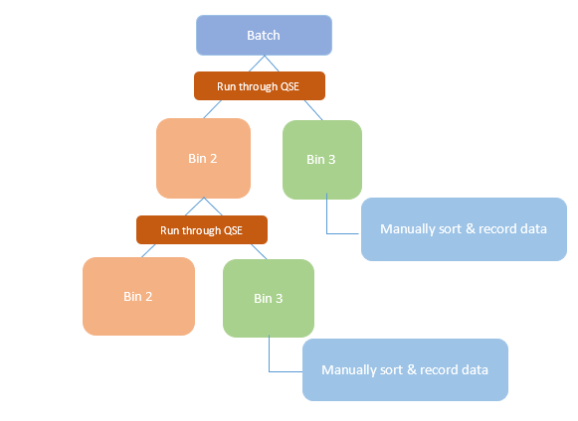
Figure 4 The experiment sorting process
Sorting thresholds
In this experiment, batches were all from the same female donor (Viking 60-01N, Albert Lea Seed, MN), in the assumption that the settings we set for sorting would likely be the most effective among all batches we would run through the sorter. The method of this experiment: (1) to run the entire batch, (2) manually sort kernels in Bin 3, counting the total number of putative haploids and diploids, (3) rerun Bin 2 (diploid bin) from the first run, (4) manually sort kernels in Bin 3 from the second run, counting the total number of putative haploids and diploids.
The QSE evaluates each kernel based on probability; what is the probability of the kernel being a haploid or a diploid based on multispectral imaging? In this study, the focus was to achieve high haploid recovery due to small batch sizes. To accomplish this, the sorter’s thresholds was adjusted to create a very low probability of a haploid being missorted into the diploid bin (Bin 2). The QualySense Qsorter® Explorer User Guide: Haploid/ Diploid Maize Sorting Application best explains the machine’s thresholds and their effect on purity, recovery, and sorting speed.
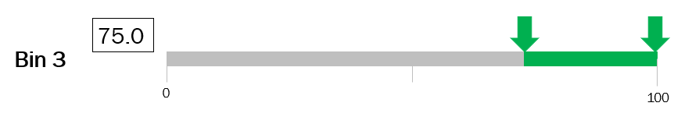
Figure 5 An example of the QSE’s experimental panel for adjusting Bin 3’s thresholds
The relationship between the upper limit for Bin 3, speed and recovery is as follows:
• Upper Bound ↓ → Haploid Recovery ↑ & Sorting Speed ↓
• Upper Bound ↑ → Haploid Recovery ↓ & Sorting Speed ↑
The upper limit for Bin 3 will ultimately affect haploid recovery and sorting speed by evaluating images for diploids. For the focus of this experiment, haploid recovery will be discussed. If one increases the upper limit of Bin 3, the “less picky” one is telling the sorter to be when evaluating a kernel. The QSE will sort kernels into Bin 2 that it deems diploids even when it is less sure it is so. Thus, haploid recovery decreases with a greater risk of misclassifying haploids into the diploid bin (Bin 2). If one decreases the upper limit for Bin 3, the “pickier” the machine is when judging a kernel. The QSE must be “confident” a kernel is a diploid based on parameter settings before discarding it. Thus, increasing haploid recovery (QSorter® Explorer). It is recommended to keep the upper bound at 100.0.

The relationship between the lower limit for Bin 3, haploid purity is as follows:

• Lower Bound ↑ → Haploid Purity ↑
• Lower Bound ↓ → Haploid Purity ↓
If one increases the lower limit of Bin 3, the “surer” the sorter must be when deciding whether a kernel is a haploid. Meaning, questionable kernels, or kernels that may not confidently meet haploid or diploid parameters, have lower odds of being sorted into Bin 3 and most likely be selected as diploids. This setting runs the risk of missorting haploids into Bin 2, with the diploids. Consequently, if one decreases Bin 3’s lower limit, the “less sure” the sorter can be that a kernel is a haploid to sort it as one, into Bin 3. Thus, haploid purity will go down but raise haploid recovery as a result (QSorter® Explorer).
If one desires a higher batch purity (fewer diploids sorted into Bin 3), increase the lower limit to 75-80%. To ensure more haploids are sorted into Bin 3, one would decrease the lower limit to 70-65%, lowering purity and raising recovery. As a result of this information, for this experiment, it was decided to set Bin 3’s lower limit to 65%. Thus, telling the sorter to be less picky when evaluating haploids and to sort questionable kernels as haploids (QSorter® Explorer). It is recommended to keep the lower bound above 60.0.
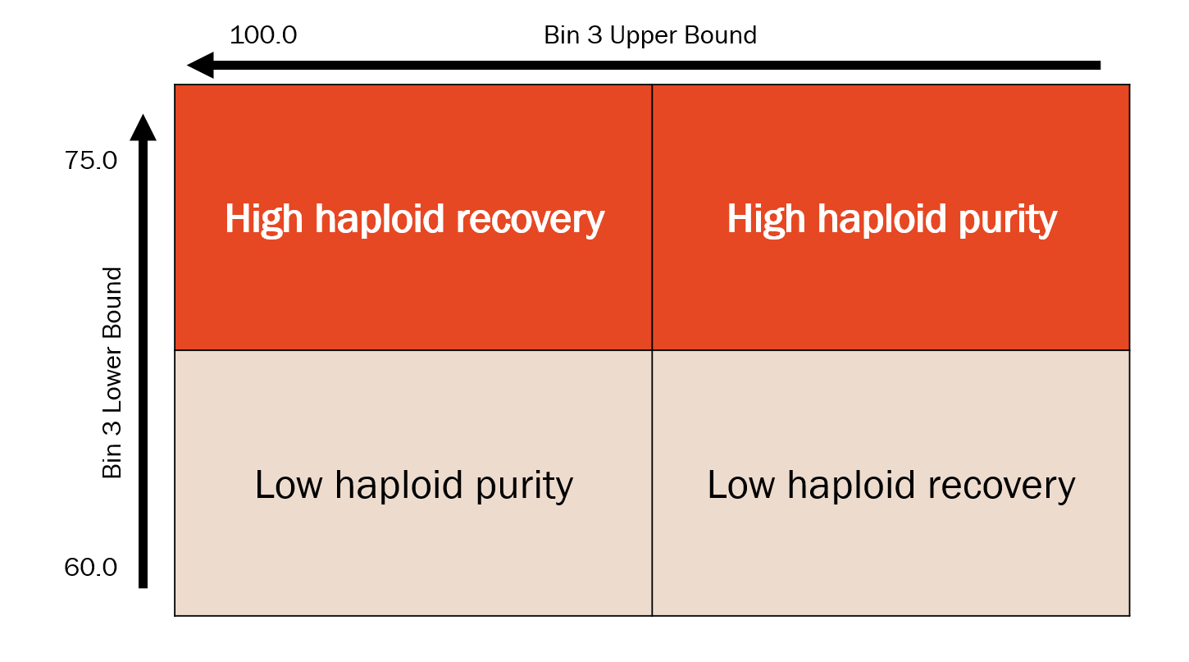
Table 1 Threshold effects on haploid purity and recovery
Data acquisition

Data regarding haploid recovery was the main interest of this experiment. We wanted to understand how well the QSE recovered all of the haploids from different batches and whether a second run was necessary or economical. Other statistics and rates were gathered such as true positives, true negatives, false positives, and false negatives.
True Positive (TP): The truth is positive, and the test predicts a positive.
True Negative (TN): The truth is negative, and the test predicts a negative.
False Negative (FN): The truth is positive, but the test predicts a negative: Type II error in statistics.
False Positive (FP): The truth is negative, but the test predicts a positive: Type I error in statistics.

For the focus of this experiment:
Haploid Recovery
(HR)
TP/TPm

False Discovery Rate (FDR)
FDR=FP/TP+ FP

False Positive Rate (FPR)
FPR=FP/TNm

False Negative Rate (FNR)
FNR=FN/TPm

False positive rate: The number of diploids the QSE incorrectly recognized as a haploid divided by the number of diploids known in the entire batch.
False negative rate: The number of haploids the QSE incorrectly recognized as a diploid divided by the number of haploids known in the entire batch.
False discovery rate: The number of diploids the QSE incorrectly recognized as a haploid divided by the number of haploids and diploids sorted into Bin 3.
Haploid recovery rate: The number of haploids the QSE correctly recognized as a haploid divided by the number of haploids known in the entire batch.

CHAPTER 3
RESULTS

Haploid sorting purity
To evaluate batch purity, we must strictly look at the data from Bin 3. This includes false positives and true positives.
First Run: Bin 3
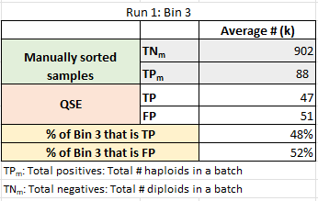
Of the kernels sorted into Bin 3 on the first run, an average of 47 kernels were haploids (TP), making up 48% of the kernels within the bin. This means that those kernels were correctly identified and sorted by the QSE. Corresponding to this data, the average batch had 51 diploids (FP) sorted into Bin 3, making up 52% of the bin. So, 52% of the bin was kernels falsely identified as haploids.
Table 2 Run 1 results

Figure 6 Graph of Run 1: Bin 3 kernel distribution

Second Run: Bin 3
After collecting Bin 2 from the first run and running it once more, kernels sorted into Bin 3 were manually sorted and the results were recorded. Of the kernels placed into Bin 3 on the second run, an average of 22 kernels were correctly recognized and sorted. Bin 3 after the second run was made up of 33% of TPs. On average, 44 kernels were FPs in Bin 3, making up 67% of all kernels sorted into that bin. Therefore, 67% of Bin 3 after Run 2 were incorrectly identified kernels (diploids).
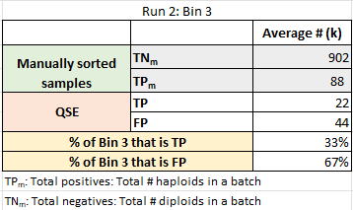
Table 3 Run 2 results

Figure 7 Graph of Run 2: Bin 3 kernel distribution

Figures 6 & 7 represent the kernel distribution in Bin 3 after one (Figure 6) and two (Figure 7) runs through the QSE. In the first run, kernels sorted into Bin 3 closely resemble around 50%. Meaning, one must produce twice the number of kernels in a doubled haploid induction field in order to harvest enough seed to cover the 50% of kernels the QSE may not recover. But, when we begin to look at the combined data of both runs and their recovery rates (as we will further in this creative component), we find that running a batch twice through the QSE may create adequate haploid recovery numbers.
Haploid sorting recovery
The effectiveness of the QSE can be evaluated based on two parameters; haploid recovery and purity. Haploid recovery can be evaluated by comparing the sorting data from the QSE with our manual pre-screening data. Each batch was sorted manually before being run in the QSE to obtain control numbers. It is important to note that the initial manual sorting serves as a “standard,” disregarding the fact that manual sorting is prone to human error and biases.
True Positive
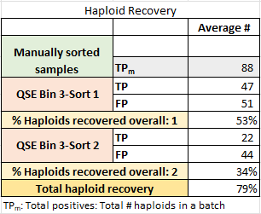
True positive kernels (TP) are haploids correctly sorted into Bin 3. An average of 47 TP kernels per batch were sorted into Bin 3 on the first run. The second run average was 51 kernels.
Table 4 Haploid recovery summary table

TPs help give accurate haploid recovery data. The number of TPs, or correctly identified haploids sorted into Bin 3, from both runs can be added together, divided by the number of total haploids within the batch, and multiplied by 100 to find the percentage of total haploids recovered overall.
Looking at the number of TPs gathered from both Runs 1 and 2, we can see there is a benefit to running Bin 2 more than once. An average of 53% of a batch’s total number of haploids were recovered from the first run. Run 1 and 2 combined, produce an average of 79% of the total number of haploids to be recovered. As shown in Figure 8, in some cases, 100% of the total number of haploids are recovered after two runs.

Figure 8 Graph of haploids recovered in sort 1, 2, and overall
High haploid recovery (HR) was originally thought to be directly correlated with a false positive rate. If thresholds were set to sort questionable kernels in favor of haploids to collect the maximum number of haploids in Bin 3, then we thought there would be a higher number of missorted diploids as a result (FP). In contrast, the data does not show a strong relationship between the number of haploids recovered overall and the false positive rate. Because of this, we are now led to believe sorting accuracies are determined almost strictly by the expression of the purple color gene within the kernel. Figure 9 depicts this relationship.

Figure 9 Graph of the relationship between FPR and HR

False Positive
Total false positives (FP) can be determined by adding the total number of diploids sorted incorrectly into Bin 3. On average, 51 kernels were incorrectly sorted as haploids in Run 1. False discovery rate (FDR) is determined by taking FP divided by FP plus TN in Bin 3. By calculating this, we can see that diploids made up 52% of the number of kernels in Bin 3. In Run 2, 44 kernels were thought to be haploids when they were not. 67% of all the kernels sorted by the QSE into Bin 3 were diploids, not haploids. To determine the total false positive rate (FPR), FP is divided by the total number of diploids within a batch and multiplied by 100. Using this rate, we can determine the total percentage of diploids incorrectly sorted into the haploid bin (Bin 3).
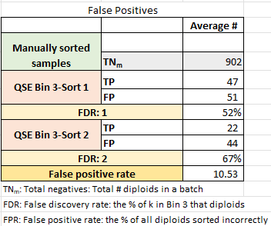
Table 5 False positive summary table
A high false positive rate is expected with Bin 3 lower limits set to 65%. The sorter was programmed to sort a higher percentage of questionable kernels as haploids. Again, achieving a high recovery rate of haploids was the goal of this experiment.
False Negative
The difference between the total number of haploids within a batch and the haploids recovered tells us our number of false negatives (FN). These were the number of haploids the QSE falsely sorted as diploids. An average of 41 haploids were missorted into Bin 2 during the first run. Thus, making up an average of 47% of the total number of haploids in the entire batch. To calculate the number of FN the QSE sorted on Run 2, we subtracted TP from Run 2, from FN from Run 1. This is because we run only Bin 2 for the second run which doesn’t contain the haploids recovered from Run 1. The number of kernels, on average, which were mistakenly identified as diploids were 19, only making up 22% of the total number of haploids within an entire batch. The total number of haploids missorted will only equal the % of FN in Run 2 because we would have rerun all of the FN from the first run. A false negative rate (FNR) was determined by dividing the total number of haploids in a batch by the number of FN.
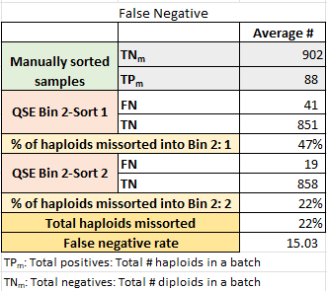
Table 6 False negative summary table

Comparing inducer lines
The expression of R1-nj depends not only on environmental factors but also on the genetic background of the haploid inducer line. The visual appearance of the haploids and diploids strongly affects the ability to sort batches correctly, whether manually or automatically. Many breeding programs are searching for an inducer with consistent inducing rates and strong color gene expression. The QualySense User Guide depicts clear and difficult haploids and diploids, including the thresholds recommended for each.

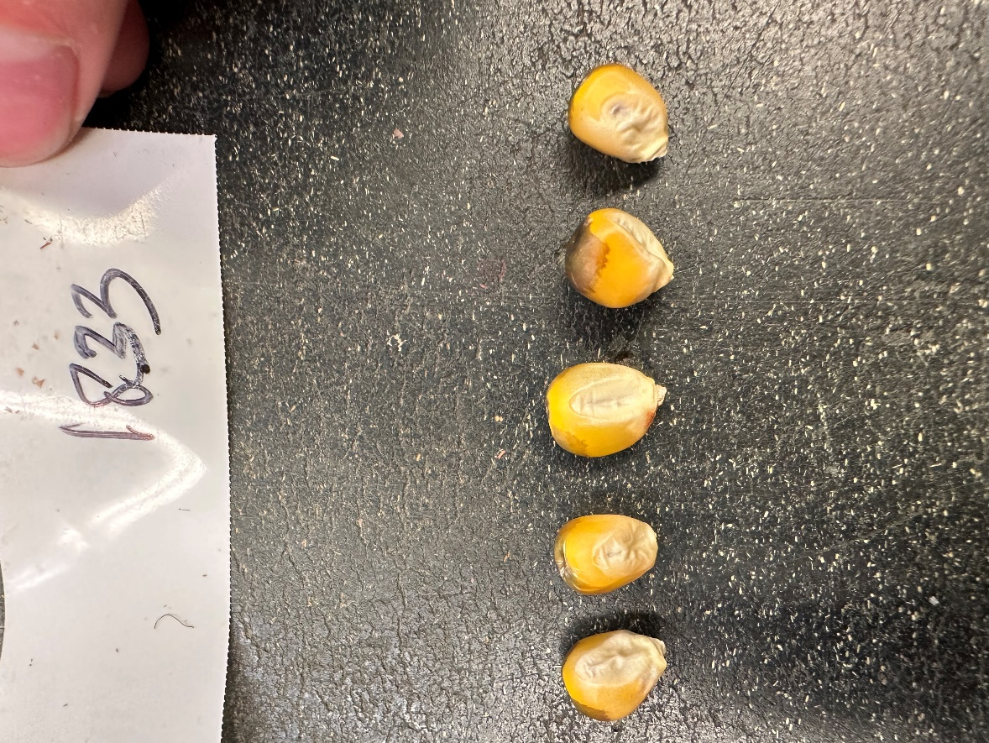
From the batches (Male Locseq) run for this experiment, the three with the highest haploid recovery rate and the three with the highest rate of false positives are pictured below.
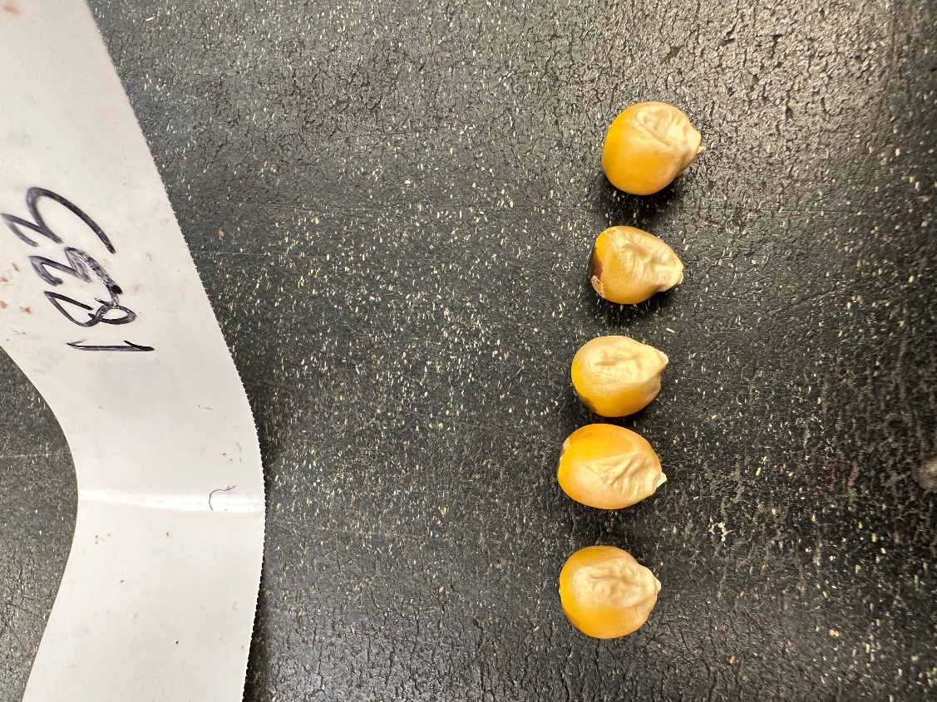
Male Locseq with high haploid recovery rates
HAPLOIDS DIPLOIDS
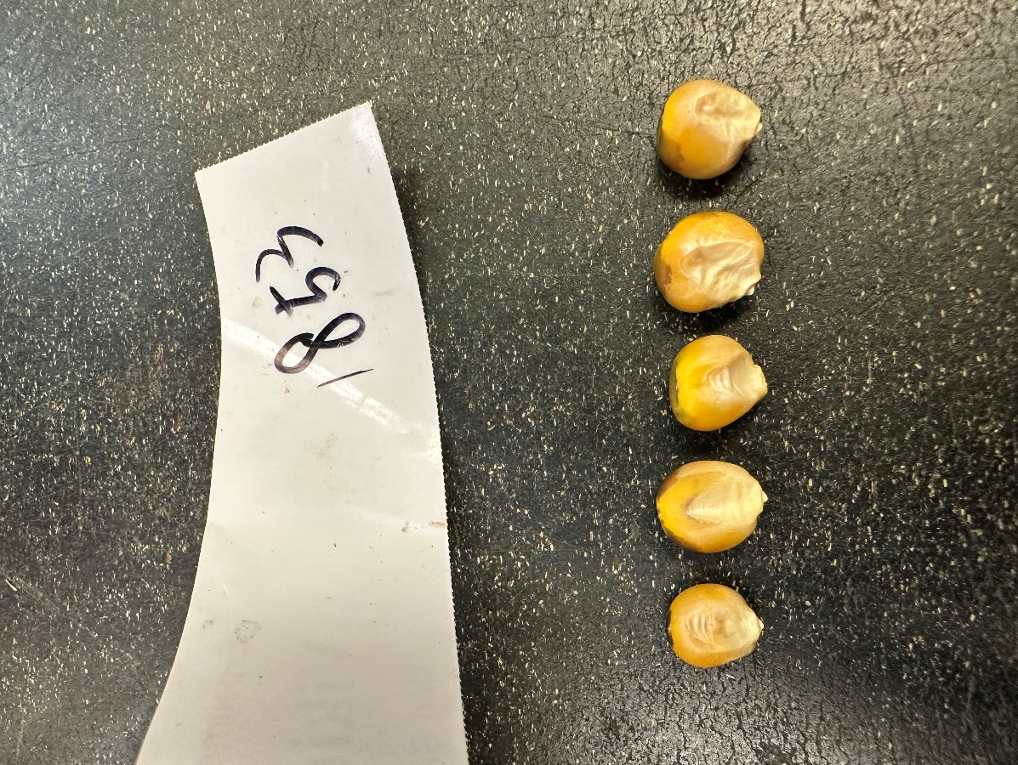
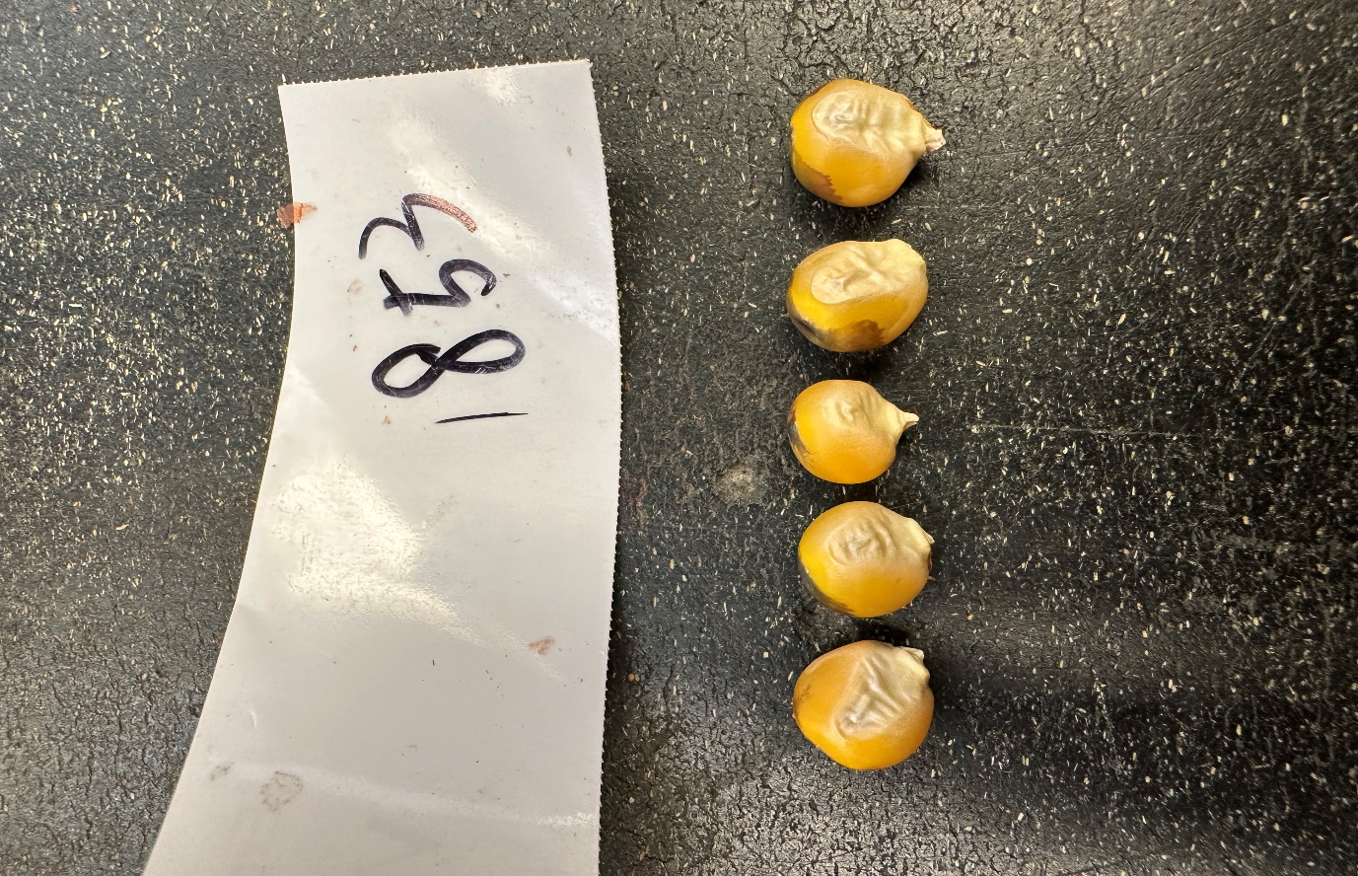
1833

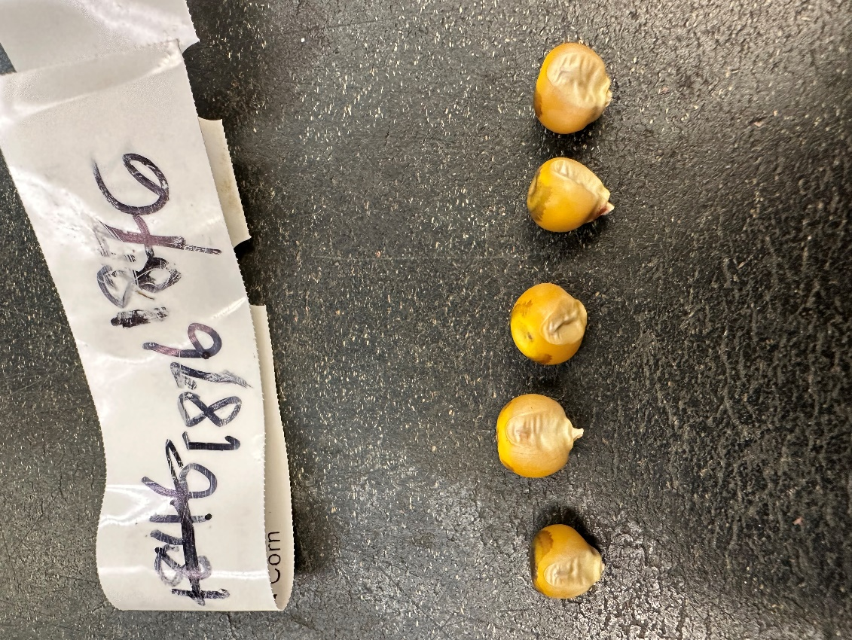
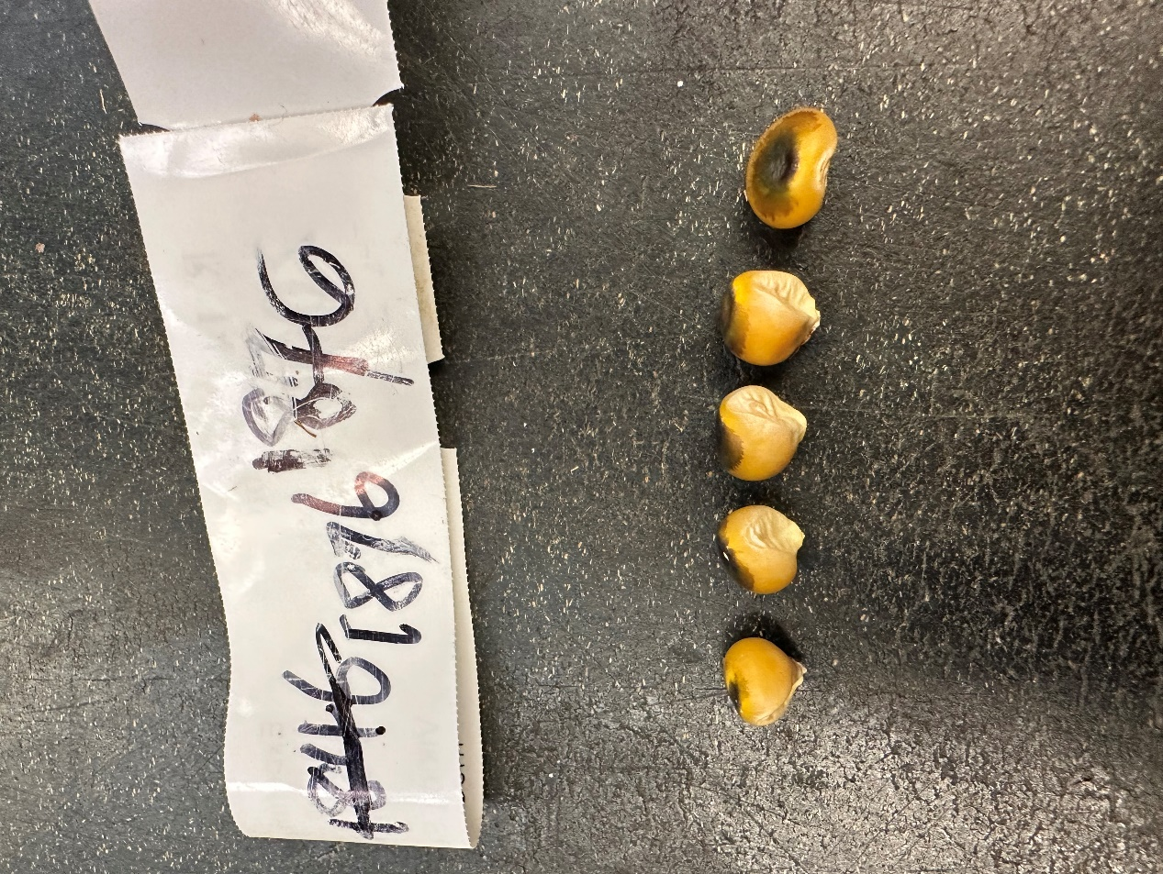
1853

1876

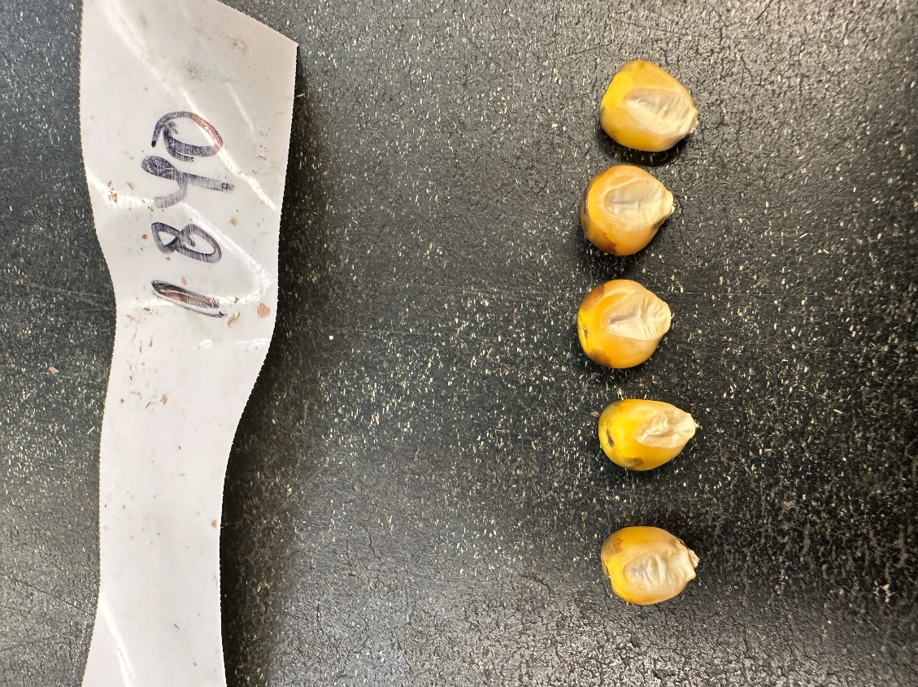
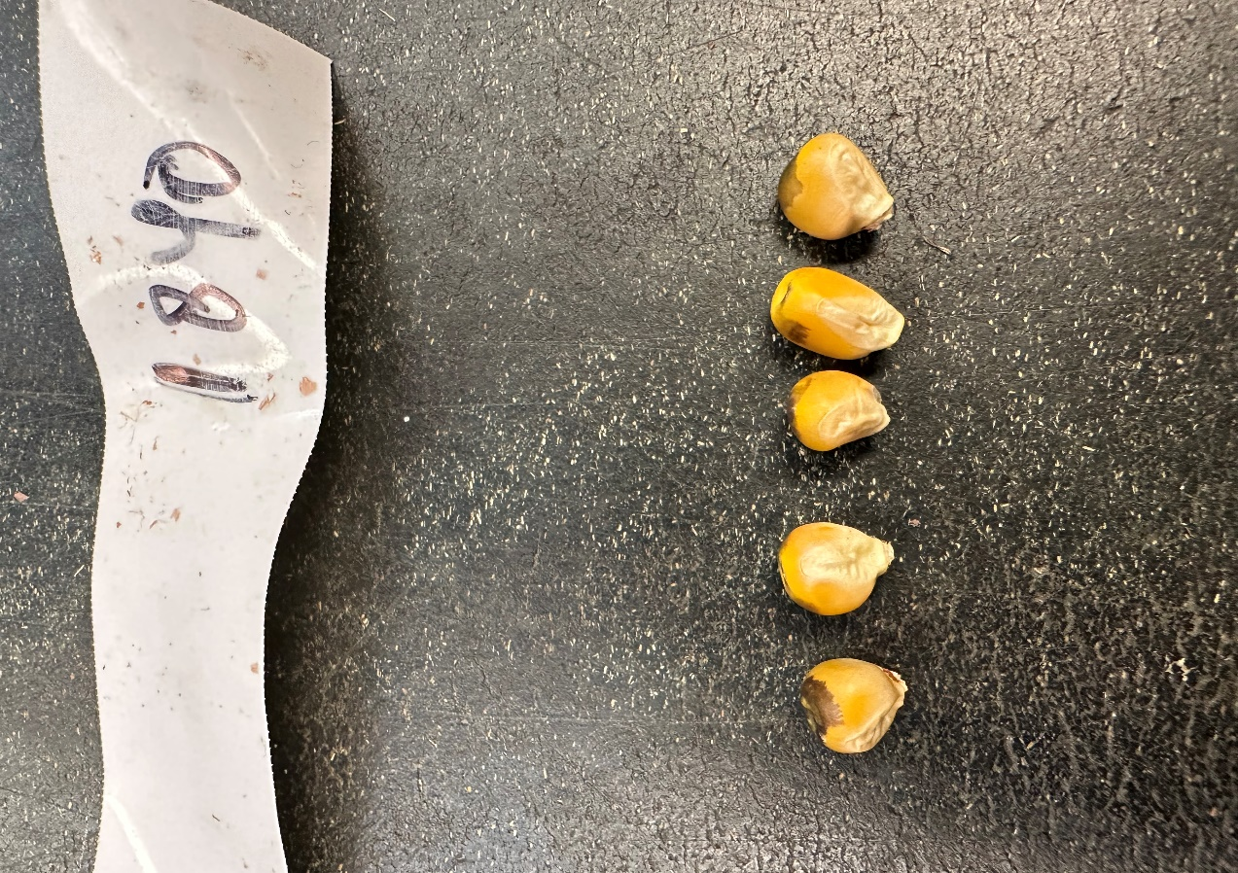
Male Locseq with high false positive rates
HAPLOIDS DIPLOIDS
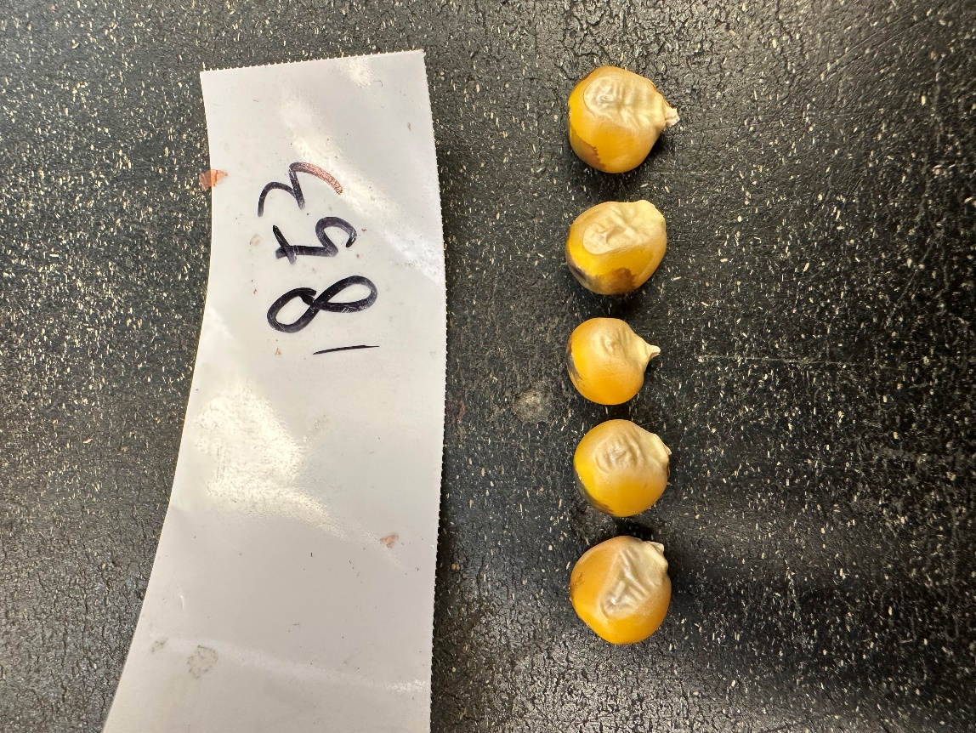
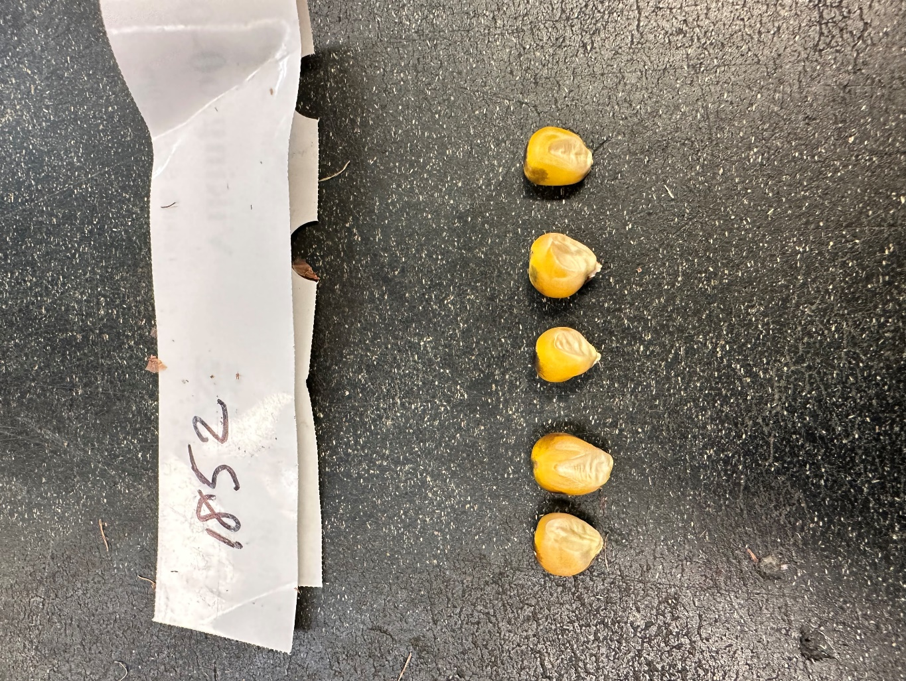
1840

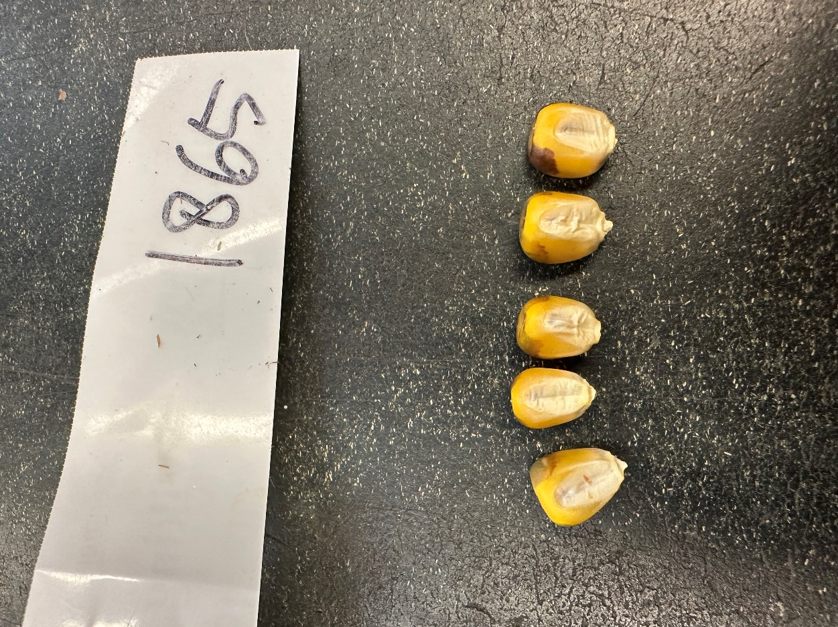
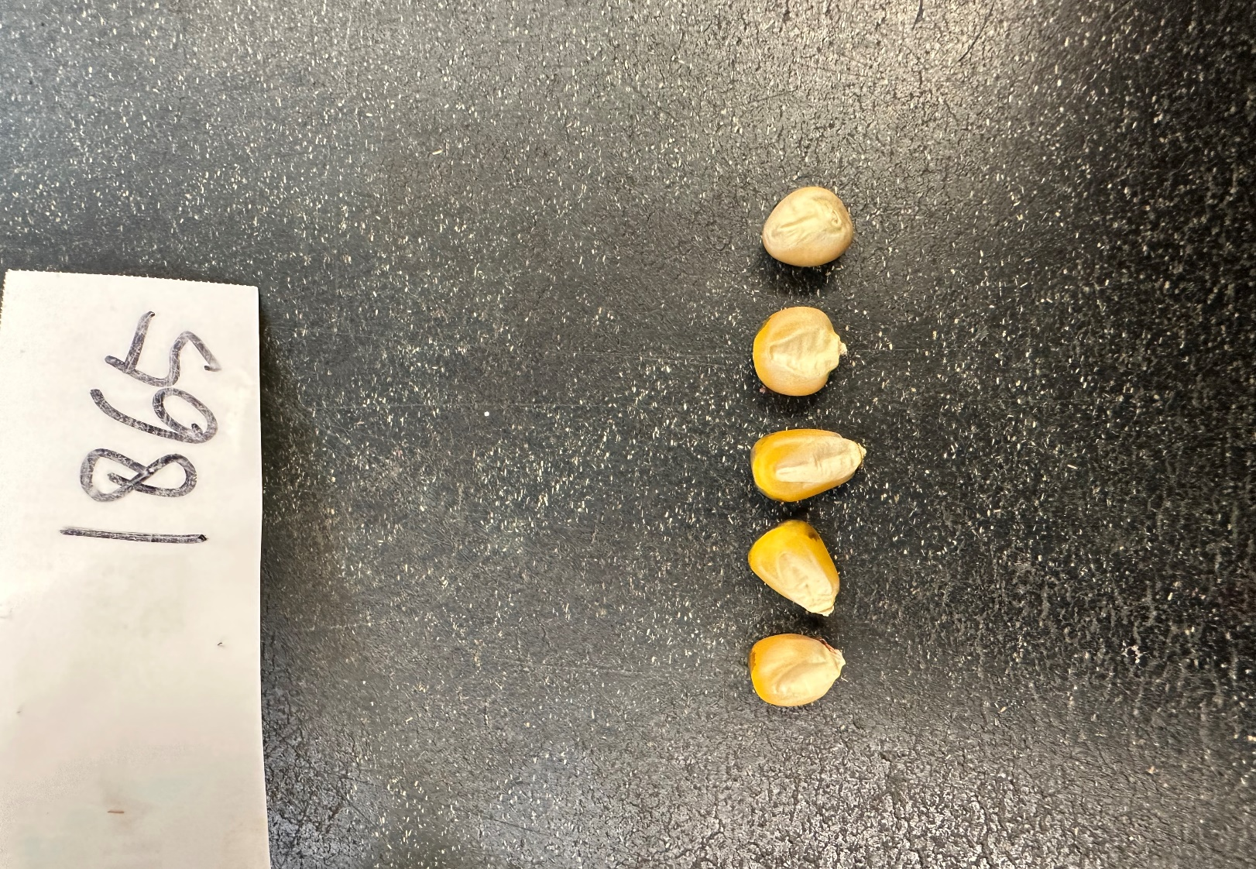
1852
Figure 12 (a-l) Comparing haploids and diploids from 6 batches

1865
CHAPTER 4
DISCUSSION

The objective of this experiment was to evaluate the QSE’s effectiveness in obtaining the maximum haploid recovery and maintaining batch purity while reducing time and other resources compared to manual sorting. DH technology offers a fast and effective route to producing completely homozygous lines in two seasons, rather than the many seasons of selfing a maize plant, only resulting in residual heterozygosity (Chaikam, 2019). Considering this, DH technology offers the most significant advantage to maize cultivar creation, being the reduced time to commercialization (Seitz, 2005; Bordes et al., 2006).
Market groups
Both small research settings and larger breeding programs can use automated sorting as a method of recovering haploids from a mixed batch containing diploids. In research settings harvesting small batch quantities of a couple of thousand kernels, batches must be analyzed with maximum accuracy to recover all haploid kernels. The goal is both haploid recovery and batch purity. On the contrary, practical breeding stations have the goal of fast sorting speed and decreasing batch sizes. These stations often send their seed to be manually sorted by a third party, so recovery of all haploids is of little concern. Instead, the priority is saving time and costs on shipping. In prior months of using the QSE for different projects, the sorter was used to extract a specific number of kernels from batches containing tens of thousands of kernels. In that case, a formula considering induction rate and the average number of diploids missorted helped produce a specific number of seeds that needed to be sorted into Bin 3 to reach desired haploid quantities.
Economics
The practical application of the QSE is for extracting a desired number of haploids from a large batch rather than recovering every haploid kernel within a batch. Although running a small batch through the QSE twice produced almost an average of 80% of the total number of haploids to be recovered, it is unfeasible to expect the QSE to recover 100% of all haploids consistently, today. In this case, potentially manual sorting is the best-case scenario for research programs. But along with this, the overproduction of seed in typical breeding settings may not be the most economical option, but rather a more accurate automated sorting.

Steps that would incur costs that a breeder must consider for each option.

Small research project
- Smaller growing areas/fields
- Smaller # of induced rows
- Less labor for planting, management, harvesting, etc. for smaller induction fields
- Manual sorting of smaller batches
  - Increased labor
  - Increased sorting time
- Shipping costs of smaller batches
- Batches are potentially shipped later due to sorting time

Breeding programs
- Larger growing areas/fields
- Larger # of induced rows
- More labor for planting, management, harvesting, etc. larger induction fields
- Automatically sorting large batches (QSE)
  - Decreased labor
  - Decreased sorting time
- Shipping costs of smaller batches
- Third-party manual sorting
- Batches are potentially shipped quicker due to sorting time
In Table 7 below, are the estimated costs and the number of doubled haploids produced in both research and breeding programs sorting haploids with and without the QSE.
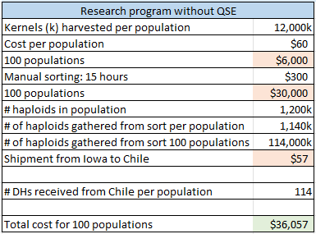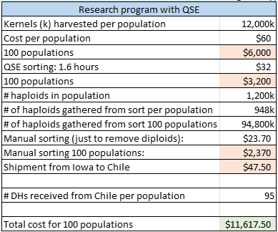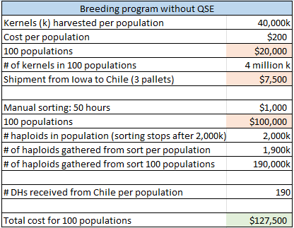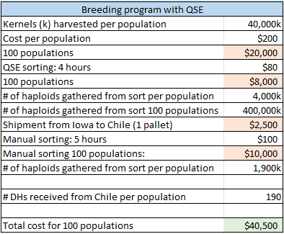
Table 7 (a-d) Estimated costs of programs with and without using the QSE for haploid sorting
Data was formulated from the following averages:
Manual sorting: 800k/h
Automatic sorting: 10,000k/h
Salary: $20/h
Planting: $60/12,000k
Shipping:
$5 per 10,000k or
$2,500 per pallet
QSE sorting haploid recovery after 2 runs: 79%
Manual sorting haploid recovery: 95%
Average induction rate: 10%

From the estimated costs, we can conclude that using automated sorting for large batches in a breeding program has a substantial economic impact. The money saved from shipping costs and hours spent sorting is the main contributors. Although there is a difference in the cost of haploid sorting in research programs using the QSE and not using it, the number of DHs that are received after doubling is lower using the QSE than only manually sorting. The QSE has lower haploid recovery rates than manual sorting. As stated before, recovering every haploid from a small batch is crucial to the success of a research program.
The future of the QSE
It is important to note that in this creative component, manual sorting was used as a standard rather than a third independent method such as germinating seed to score based on the presence of a purple root, flow cytometry of germinated seedlings, DNA analysis, and more. Manual sorting is prone to human error as biases, what one person identifies as a haploid, another may not. One may wonder if the QSE has a better “eye” than humans, but haploid recovery was never over 100%. Meaning, the QSE didn’t seem to catch any haploids that we didn’t find during our manual pre-screening.
Before running kernels through the QSE, broken kernels, embryoless kernels, diseased kernels, large cobs, dust, and debris were removed from the batch. These are all factors that could have affected sorting effectiveness.
There are many different thresholds and settings that can be changed to alter the effectiveness of the QSE. In this experiment, we had only changed Bin 3’s lower limit, while we could have changed the upper limit, the limits of Bin 2, kernel size, and sorting speed. The QSE offers a threshold tool, a way of calculating a batch’s optimal thresholds by running a sample of known haploids and diploids from the batch. Thus, the sorter identifies the clarity of each and recommends sorting settings. These are all options that could be considered before running.
QualySense continues to improve its applications and sorting accuracies by developing new software updates. More recently, an update was released improving multispectral imaging in maize and focusing on imaging of not only the embryo of the kernel but the aleurone as well. Thus, improving the ability to sort outcross kernels into the diploid bin. The focus of different cameras and camera angles on more areas of the kernel may improve sorting effectiveness.
The future of automated sorting
Fully automated high-throughput haploid sorting has a promising near future in retaining a desirable level of accuracy while meeting major constraints of time, workforce, and budget (Dermail, 2023). The conventional, manual sorting of haploids based on the color of the aleurone and embryo, is slow and prone to human error. Along with this, sorting kernels by oil content often still requires manual sorting due to embryoless kernels having similar oil content to haploids (Wang et al., 2016). NMR sorting systems show an average screening time of 4 seconds per kernel, while the QSE can sort around 30 kernels per second (Wang et al., 2016). In contrast, the cost of the QSE is not easily affordable for small research and breeding operations. Thus, automated sorting for small batches may not be the best economically.
Automation of haploid identification using genetic markers such as R1-nj or high oil markers is a reality with continuous development by several research groups. In the future, inducer lines equipped with multiple genetic markers (e.g., R1-nj, high oil, and red root) could be a key enabler to high throughput and fool-proof haploid sorting. Therefore, significantly reducing cost and time, and managing false positives. Potentially, the future of haploid sorting doesn’t just lie with visual sorting or compositional sorting, but rather the use of both. As stated, running a batch twice through the QSE results in higher haploid recovery. Instead of both runs using the sorter’s multispectral imaging, the second run could use the machine’s NIR function. Therefore, identifying a haploid by the R1-Navajo marker and oil content traits.
Maintenance of inducer lines also entails frequent testing of haploid induction rates because natural selection acts strongly against this trait (Melchinger et al., 2016). Multiple studies showed a selective disadvantage for haploid induction, resulting in segregation distortion (Barret et al., 2008). Optimizing chromosome doubling protocols based on non-hazardous chemicals and improving effectiveness is another important area of research. Improving the prior conditions can improve the quantity and quality of DH production, eliminating the need for overproducing seed (Chaikam et al., 2019). Together, with the future of doubled haploid advances such as the ones mentioned in this creative component, the full potential of automated sorting and DH technology will be realized.

References
Atlin, Gary N, et al. “Rapid Breeding and Varietal Replacement Are Critical to Adaptation of Cropping Systems in the Developing World to Climate Change.” Global Food Security, U.S. National Library of Medicine, Mar. 2017, https://pubmed.ncbi.nlm.nih.gov/28580238/.
Barret, P, et al. “A Major Locus Expressed in the Male Gametophyte with Incomplete Penetrance Is Responsible for in Situ Gynogenesis in Maize.” TAG. Theoretical and Applied Genetics. Theoretische Und Angewandte Genetik, U.S. National Library of Medicine, Aug. 2008, https://pubmed.ncbi.nlm.nih.gov/18516584/.
Bordes, J, et al. “Doubled Haploid versus S1 Family Recurrent Selection for Testcross Performance in a Maize Population.” TAG. Theoretical and Applied Genetics. Theoretische Und Angewandte Genetik, U.S. National Library of Medicine, Apr. 2006, https://pubmed.ncbi.nlm.nih.gov/16432736/.
Chaikam, Vijay, et al. “Doubled Haploid Technology for Line Development in Maize: Technical Advances and Prospects.” Theoretical and Applied Genetics, vol. 132, no. 12, 2019, pp. 3227–3243., https://doi.org/10.1007/s00122-019-03433-x.
Khan, T.N., and J.S. Croser. “Pea: Overview.” Encyclopedia of Grain Science, Elsevier, 28 Nov. 2004, https://www.sciencedirect.com/science/article/pii/B0127654909001269.
Liu, Zhixin, et al. “Maize Doubled Haploids.” Plant Breeding Reviews, 2016, pp. 123–166., https://doi.org/10.1002/9781119279723.ch3.
Melchinger, Albrecht E., et al. “Rapid and Accurate Identification of in Vivo-Induced Haploid Seeds Based on Oil Content in Maize.” Scientific Reports, vol. 3, no. 1, 2013, https://doi.org/10.1038/srep02129.
Qu, Yanzhi, et al. “Improving the Sorting Efficiency of Maize Haploid Kernels Using an NMR-Based Method with Oil Content Double Thresholds.” Plant Methods, vol. 17, no. 1, 2021, https://doi.org/10.1186/s13007-020-00703-4.
“QSorter® Explorer.” QualySense, https://www.qualysense.com/qsorter-explorer.
Rajcan, I., et al. “Plant Genetic Techniques: Plant Breeder's Toolbox.” Comprehensive
Biotechnology (Second Edition), Academic Press, 14 Oct. 2011, https://www.sciencedirect.com/science/article/pii/B978008088504900252X.
“Seeds & Grains.” QualySense, https://www.qualysense.com/commodities .
“Sensitivity and Specificity.” Wikipedia, Wikimedia Foundation, 26 Jan. 2023, https://en.wikipedia.org/wiki/Sensitivity_and_specificity.
Singh, Dhan Pal, et al. “Haploidy and Polyploidy in Crop Improvement.” Plant Breeding and Cultivar Development, Academic Press, 29 Jan. 2021, https://www.sciencedirect.com/science/article/pii/B9780128175637000088.
Vanous, Kimberly, et al. “Generation of Maize (Zea Mays) Doubled Haploids via Traditional Methods.” Current Protocols in Plant Biology, 2017, pp. 147–157., https://doi.org/10.1002/cppb.20050.
Wang, Hongzhi, et al. “Fully-Automated High-Throughput NMR System for Screening of Haploid Kernels of Maize (Corn) by Measurement of Oil Content.” PLOS ONE, vol. 11, no. 7, 2016, https://doi.org/10.1371/journal.pone.0159444.
Weber, David F. “Today's Use of Haploids in Maize Plant Breeding.” Advances in Agronomy, Science Direct, 17 Dec. 2013, https://www.sciencedirect.com/science/article/pii/B9780124202252000030.
APPENDIX
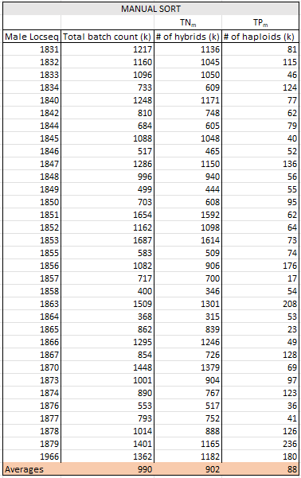
Table 9 Pre-screening manual sort
Table 8 Summary Table
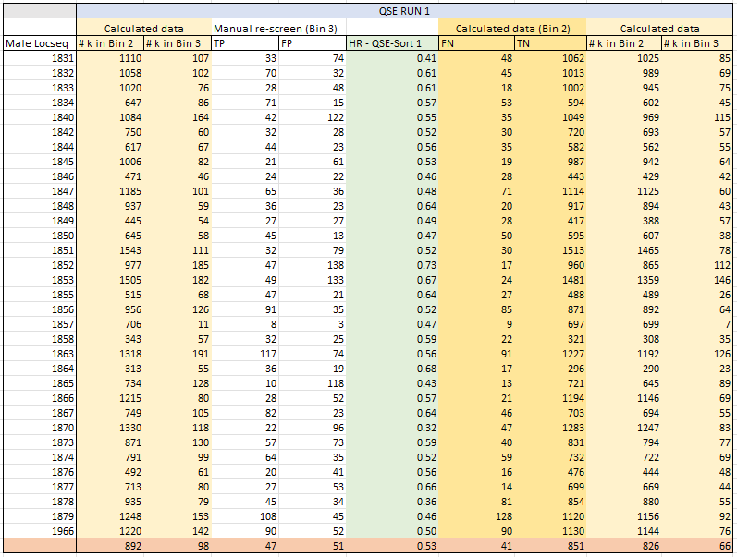
Table 10 Extract of table 2: First sort
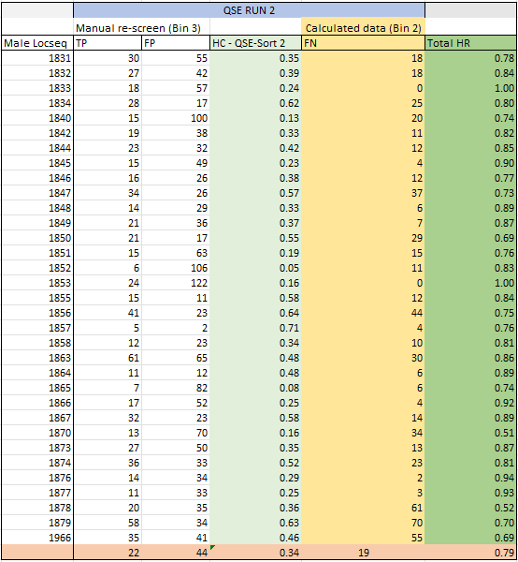
Table 11 Extract of table 3: Second sort

