National FFA Convention Planning Guide
By:
Skylynn Fleming

Abstract 3
Chapter 1: Introduction 4
Introduction 4
Purpose and Objectives 4
Need 5
Chapter 2 6
Literature Review 6
Chapter 3 9
Methods and Procedure 9
Chapter 4 11
Product 11
State vs National 14
Schedule 14
Packing List 16
Travel Arrangements 16
Funding 17
Hotels/Airbnb 17
Insurance 18
Restaurants 18
Registration 19
Applications 19
Contests 22
Chaperones 22
Tours 22
Things to do 22
Educational Aspects 23
Student Activities 23
Ag Teachers Checklist 32
Reflection 32
Timeline 32
Chapter 5 34
Reflection 34
What is Recommended? 34
What would I change? 35
References 36

Abstract
National FFA Convention and Expo is an annual conference that all FFA members are able to attend. The National FFA Convention is able to highlight different chapters throughout the United States on their successes throughout the year. There are opportunities to provide different learning experiences with seminars, sessions, and many different booths for students to network about their future. The National FFA Convention and Expo are able to provide FFA members with inspiration to make a change, become better leaders, and make an impact. Throughout my time as an ag advisor, it is always challenging to remember everything that needs to happen for the convention trip to be successful. I have looked for resources and always seem to forget a few things. I soon found out through casual conversations that other newer FFA advisors have the same issue. Therefore a thought to create a guide that other chapters can utilize to make sure they have everything they need for a successful convention.

Chapter 1: Introduction

Introduction
When an individual accepts a position as an agriculture instructor at the secondary school level, typically they are also the FFA Advisor. Some of the most notable trips that anyone involved with FFA includes are conventions. This would include the state level and national level. Planning for one of these trips can be quite overwhelming and there are plenty of things that are easy to miss. Knowing this, I am creating a Convention Planning Guide to support FFA Advisors who are new or experienced.
When many teachers take students to a convention for the first time they do not know where to start. It can be quite overwhelming with the different tasks needed to be done to plan a successful trip for all students. Having the trip be educational, safe, and entertaining are the main goals of these conventions. A new teacher should be able to utilize this guide to find success in planning to go to convention the first time and years following.

Purpose and Objectives
- Create a guide that allows any FFA Advisor to utilize in the planning process of going to the National Convention.
- Provide a step-by-step how-to for beginning teachers or educators in a one-teacher program.
- Provide enough information that an individual can alter and change as needed.
- Give an estimated timeline of when tasks need to be completed.

Need
Even though a vast majority of teachers have students taught for a semester to complete their education degree, agriculture instructors have a very interesting timeline with different activities and contests spread out throughout the year. This can make organization and remembering important details quite challenging. One of the largest events many chapters attend is the National FFA Convention. However, there is a lot of planning involved and many different items that can easily be overlooked. This is specifically true for first year teachers or individuals in a one teacher program. There is plenty of information to keep track of. Providing these individuals with a guide that they can use at their own discretion can provide them with the information and resources needed to plan a successful and smoothly run trip to the National Convention.

Chapter 2

Literature Review
One difficulty of preparing to take students to the National FFA Convention is knowing all of the different steps and tasks involved with planning for a large event and attending it. Even though the National FFA Organization website has a decent amount of information, it still lacks many items that could be considered with an event of this magnitude. With all of the information provided, nothing is consolidated into one source.
The National FFA Convention has been held in Kansas City, Missouri, Louisville Kentucky, and Indianapolis, Indiana (IUPUI). If we think about the growth of an organization as a whole, it started out with 33 delegates from 18 states at the first convention. Now the organization has more than 760,000 members. It has been an organization that has grown and advanced continually. It has now grown and integrated into every state in the United States, the U.S. territories, and even in some of the United States largest cities (IUPUI). Recognizing that there are over 760,000 members enrolled in the FFA, most are students that come from Texas, California, Georgia, Florida, and Oklahoma. With this in consideration, we can see that where the National Convention has been held is more toward the Eastern side of the United States. This can limit the number of chapters in the Western United States that are able to attend the convention.
This could easily limit the number of members and chapters in attendance due to travel barriers. This would include flights or a possibility of multiple days set aside for travel. If this is the case, an agriculture instructor in charge may be limited to the number of days they can attend or the availability of substitutes. However, one positive with the pandemic that hit in 2020 is the availability of an online platform for many chapters. The initial response was challenging to put into motion because of the difficulty and unpreparedness to turn a live convention with over 60,000 participants into an all online format. The online format can provide chapters with resources to experience the convention from home (Martin Thomas Falk). With the technological advances, we also are able to notice that social media is able to make a major impact with the connections available.
Social media is present in many individuals' lives and is a direct way that people can stay in contact with each other. It's also a way that brands can communicate with the public. The National FFA Organization was able to recognize the way members are using social media and the common trends during the convention (Rogers-Randolph). Social media is a way that technology has also been integrated into the way many individuals are able to experience the National Convention and keep up with new ideas and individuals after all of the members are able to arrive home.
Many students have been able to see the discrepancies that happen to be in a rural-based area versus a more urban setting. In the article Critical theory view of the National FFA Convention, the authors highlight the struggles of having urban students integrated effectively into the organization as a whole. There are contests that allow for these students to showcase their skills and talents; however, this may be easier to achieve in a more urban setting. Even with these considerations, students are still able to create lifelong considerations of potential careers and further education due to the experiences they gain in FFA. These experiences are not limited to one item but can be recognized from participating in multiple events. (Hoyle, T. L.) There are topics that have been improved but still challenge to bridge the gap between rural and urban experiences and opportunities (Martin, Advising).
These events and trips are still able to give those attendees an experience that they may not have been previously exposed to. It can broaden their horizons by getting to talk to different companies, schools, and even individuals from around the country and U.S. territories. The convention can start “introducing students to concepts, ideas, and experiences that cannot be provided in a classroom environment” (Storksdieck).

Chapter 3

Methods and Procedure
In the designing of this guide, I knew that I wanted to have a majority of topics that many agriculture instructors and FFA Advisors would encounter. I was able to find a wide scope of the information provided by the National FFA Organization website. However, there has not been a guide that puts all of this information in an individual place for the advisor’s convenience. There are also many factors that are easily overlooked or misplaced. I created a guide that compiled a vast list of information under specific topics.
These different topics show different options that some individuals can utilize depending on the school and state policies. Many of these different topics include funding, travel considerations, and providing information on where to start. Having all of these different topics can be dependent on each other and change accordingly. In addition, I was able to provide an estimated timeline of when to get each of these items achieved. I was even able to include a couple of extra items to include reflection. Providing all of these resources and considerations in one place will allow for individuals to stay organized, stay on task, and assist with the stress of planning such a large event.
I was able to collect all of the topics and different needs that should be implemented into this guide by my own experiences and struggles with the planning. I was also able to look through social media sites where fellow ag teachers posted online. Through this, I could see commonly asked questions or comments about the convention. However, I was also able to discuss this with multiple different Agriculture Instructors and FFA Advisors to see what they would like included within this guide. This helped me compile information on what was actually useful to the advisor and what was not. They were also able to tell me what they typically forget to do. When we are able to incorporate some of those smaller details that are easily forgotten it can reduce the stress of those final items that need to be taken care of. These individuals were also able to review the guide after it was completed to see if there were any large points that were forgotten. Taking into consideration what I and other educators have experienced will be able to produce an efficient compiled guide for other FFA Advisors to utilize.

Chapter 4

Product
- State vs National
  - Traveling out of state documents/confirmation
- Schedule
  - Estimated Schedule for parents and students
- Packing List
  - Student & Teacher
- Travel Arrangements
  - Bus with other schools or drive
  - Insurance
- Funding
  - FFA Account
  - Students
  - Alumni
- Hotels/Airbnb
  - Hotel Block vs Not (Cost)
  - Airbnb
- Insurance
  - From all of the students'
  - Vehicles
- Restaurants
  - Around the area
  - Who's paying for what
- Registration
  - Where
  - When
  - Map of convention center
- Applications
  - Who's going
  - Grade checks
- Contests
  - State Level
  - National
- Chaperones
  - Additional Chaperones Needed
  - Phone Tree
- Tours
  - Going anywhere other than the convention center
- Things to do
  - Rodeo – Concert
- Educational Aspects
  - How is it an educational event
  - Why is it worth going to
- Student Activities
  - Seminars
  - Blue Room
  - Career Fair
- Ag Teachers Checklist
  - Documents Needed Printed and Virtual
- Reflection
  - Showcasing trip to school board/show the value
- Timeline

National FFA Convention Planning Guide
& Information to Consider

By Skylynn Fleming
Iowa State University
2022 Creative Component
National Convention Planning Guide
& Information to Consider

State vs National
  - Traveling out of state documents/confirmation

When traveling with students there is plenty to consider. Talk to the administration about when and where you are going. There is a good possibility that you will need to talk to the school board to follow policies put into place. Receiving approval from the school board will allow for the FFA chapter to start planning the different events that the chapter may do.

Schedule
  - Estimated Schedule for parents and students

Traveling to a convention, students, families, and fellow school teachers should be informed of what students will be doing and where they are at during this time. It is also valuable to have this put on the school activity calendar so coaches, parents, teachers, etc. are all aware of when students may be traveling. When students are selected, they should be given a more specific timeline. Parents, students, and administrators are then able to see the value in the trip and feel more comfortable with what their students will be doing while they are traveling. I also like to share this with students on google docs that way they can access an online copy.

Below is an example of a schedule that can be utilized and what students or parents should be aware of.
National Convention

Wednesday, Oct. 30th
3:15 a.m. Bag Check & Load Vehicles
3:30 a.m. Leave Lake Mills High School (FFA or School T-Shirt/Jeans)
9:00 a.m. Arrive at Lowdermans @ Macomb, IL
10:00 a.m. Leave Lowdermans (Cattle producer/auctioneer) Went to their business and home for both parts of their businesses
Lunch and Travel to Fair Oaks, IN
3:00 p.m. Dairy Tour at Fair Oaks
6:00 p.m. Leave Fair Oaks -> Indy 2 hrs 10 min
8:00 p.m. Dinner
10:00 p.m. Check into the Hotel

Thursday, Oct. 31
6:30 a.m. Ready to Leave the Hotel (In OD)
7:30 a.m. In Seats for Pre-Session
8:00 a.m. 1st Opening Session
10:00 a.m. Career Fair
12:00 p.m. Lunch/Check In
1:30 - 2:00 Meet for Workshop
3:00 p.m. Hotel to Change for Concert (Regular Clothes)
4:30 p.m. Leave for Dinner
7:30 p.m. In our Seats for Concert
11:00 p.m. In Hotel Room/Lights Out

Friday, Nov. 1
6:30 a.m. Ready to Leave the Hotel (In OD, bring a quick change for the right home)
7:30 a.m. Seats for Session
8:00 a.m. Session
10:00 a.m. Career Fair/FFA Mall
11:30 a.m. Meet/Change/Lunch
12:00 p.m. Lunch/Leave for Home
10:00 p.m. ETA Home

Packing List
  - Student & Teacher

I have provided an example of a packing list designed for students and parents to utilize. This is a useful tool for individuals to use when they are packing and if they need to go purchase something before the trip. It gives students and teachers a visual of what is useful to bring depending on what activities the chapter will be doing. For the packing list I also like to share this with students on google docs that way they can access an online copy.

Below is a general packing list that can be provided to students. I have created this on google excel so there are multiple different columns that can be utilized and changed depending on the student’s needs.

*OD – Official Dress

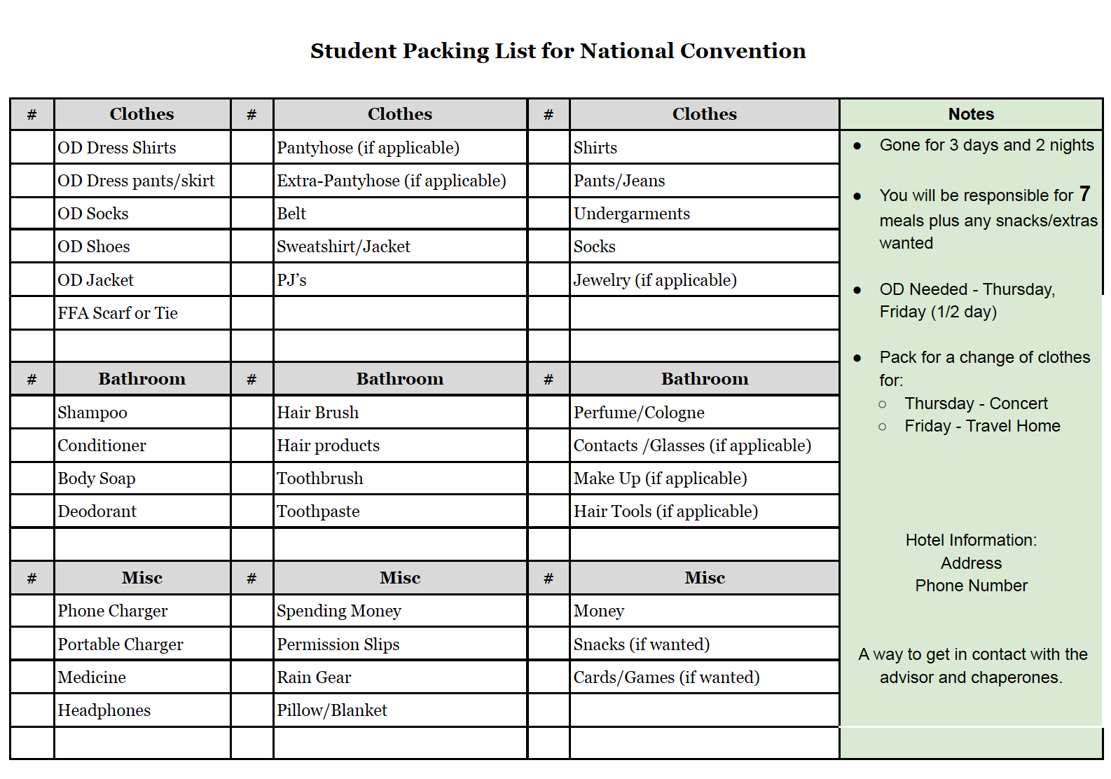

Travel Arrangements
  - Bus with other schools or drive
  - Insurance

First an individual needs to decide how the chapter is going to get to the National Convention. This can be very dependent on the geological location of the chapter. Many will drive individually, caravan with other schools, split a charter bus with other chapters around the area, or even plan flights. These are all valid ways to get to the convention center. Another consideration is what the school board will accept as a form of travel. Even so when an individual is taking a school vehicle, they need to plan out how they are going to purchase fuel and know all the insurance information. If an individual is taking a school vehicle they need to contact their transportation director. I like to contact them at the beginning of the school year so it is on their agenda and remind them a month ahead of time. This way you both can be best prepared to reserve the school vehicles. Another consideration is parking when you arrive at the convention center. This will change depending on what type of vehicle you are using or where your hotel is at. Though individuals can purchase parking passes on the National FFA Convention Website.

Parking information can be found: https://convention.ffa.org/travel-planning/

Funding
  - FFA Account
  - Students
  - Alumni

Through the entire planning period of the National FFA Convention there are many costs that come along with it. You should be aware of where the funding is coming from. It is important to know what accounts need to pay for what. What everyone should be accountable for. This can change depending on the chapter norms. Some chapters have specific costs covered by the student, chapter, or even the alumni chapter will tend to cover some of the additional costs of the National FFA Convention Trip.

Hotels/Airbnb
  - Hotel Block vs Not (Cost)
  - Airbnb

One item that can be challenging to arrange is the rooming arrangements. When over 60,000 individuals are all attending the same convention, hotel costs can be challenging to book for all your group. There are different chapters that choose to stay at hotels or an Airbnb. Again, this is dependent on school policies and what is allowed. The National FFA even has a block provided for individuals to utilize.

Below is an example of the hotel block set up by the National FFA Association

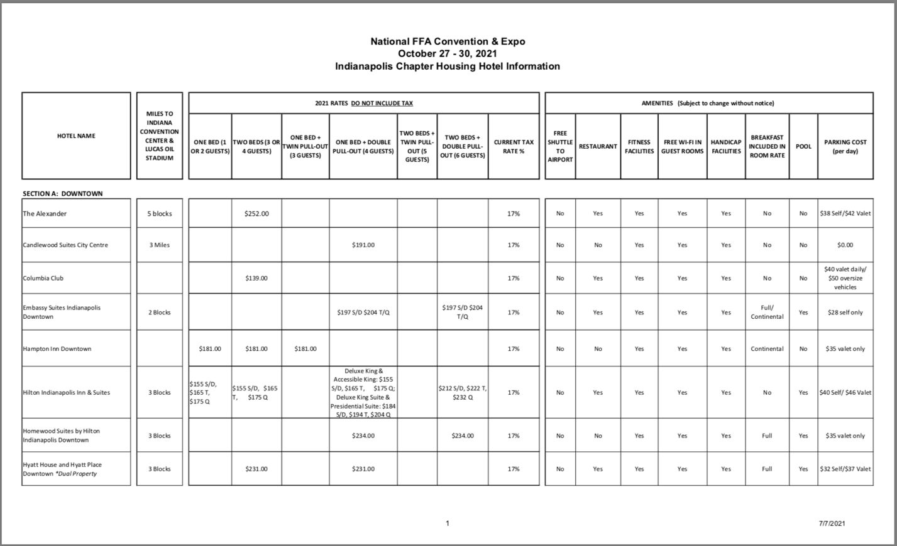
Picture provided by National FFA Organization

Insurance
  - From all of the students'
  - Vehicles

This is an item that you hope you never need to utilize but it is essential to collect if something happens. You need to know and understand what medical information is needed for students in case something were to happen. If you are the one driving or taking a school vehicle, understand what the insurance needs are in case something happens with the vehicle during travels.

Restaurants
  - Around the area
  - Who's paying for what

When taking students on a trip to understand what restaurants are around where you will be and making different reservations to the restaurants. Considering there is a major increase of people within the city it is important to be prepared for what restaurants are going to be around you.

Some Restaurants and Attractions can be found: https://www.visitindy.com/ffa21

Registration
  - Where
  - When
  - Map of convention center

You can register who will be attending the convention on the National FFA website. This will include everyone that plans on attending the convention. Each person will receive confirmation emails. Then one individual will be able to go to the registration booth and collect all of the information for the participants. On the FFA National Convention Website, there is a floor plan that shows where everything is at. This includes where different exhibits are. Registration is open and available at a wide section of times. Advisors can find this information and the times that they can check following the emails that they have received after registering how many individuals will be attending the National FFA Convention.

Registration can be found here: https://convention.ffa.org/registration/

Maps of Convention can be found here: https://convention.ffa.org/maps/

Applications
  - Who's going
  - Grade checks

When selecting students that can attend the National FFA Convention this can change depending on the school. These schools may have different requirements or interests in individuals who can attend. Though it is important to provide applications of why students want to attend, lay out the rules and regulations that include attending the convention. Also, it can showcase to students the value of this trip. Another important aspect is knowing where the students are in terms of their grades. Typically, in this type of trip students will be missing multiple days of school. Making sure the students are going to be able to keep up with the missing schoolwork will be extremely important. Below is an application that members can fill out.

National FFA Application
(Due Friday. September 24th, 2021)

Rules:

Before completing this application please be aware of the following rules. I do not expect problems from the members selected and we will discuss conduct for this trip at a later date but please be clear on what is expected of you. If you have any questions, please ask me.

- At all times on this trip, I will conduct myself in a manner to create a positive impression of myself, my advisor, the Lake Mills FFA, the Iowa FFA Association, and the National FFA Organization
- I will accept the authority of the advisors and supervisors in charge of this trip. (i.e. other advisors, chaperones)
- I will be in official dress at all times required. (No tennis shoes or black jeans allowed as part of the official dress.)
- I will not wear hats while in official dress.
- I will wear a mask anywhere it is required.
- I will not purchase or possess alcohol, tobacco, or drugs during this trip.
- I will not gamble on this trip.
- I will attend all designated sessions, workshops, and activities as assigned. I will be in the right place at the right time.
- I will be in my room and stay there after curfew time (11:00 pm or as designated), and I will be dressed and ready to leave at the designated time each morning.
- I will not leave the hotel/motel without the advisor’s knowledge.
- I understand the proper and courteous use of the telephone in my room and that I will pay any bills that I charge.
- I will travel only in areas I should be and only with the group I came to the convention.
- I understand that any infraction of any of these rules will be sufficient cause for my participation in the National Convention trip to be terminated and for me to be sent home at my own expense.
- To go on the National Convention trip, I am willing to pay $100. (Any issues can be discussed with Miss Fleming)

Signatures: _________________________ ___________________________
FFA Member Parent/Guardian

Signatures: _________________________
Other High School Teacher (In place of a recommendation letter)
Name: _______________________________

Grade: _______________________________

Years in FFA: _________________________

Degree Held: __________________________

Have you attended the National Convention before? ________ Year? _______________

Please answer the following questions thoroughly but as concisely as possible. Attach an additional sheet

1. What activities have you participated in during the past year? (Aug. 2019- Aug-2020)

2. How will your experiences at the National Convention help you contribute to the local chapter? Be specific.

3. In 100 words or less, please describe why you feel you would like to be selected to attend this activity. (First year members: this is a very important question as your activities will have been minimal to date)

I ____________________________ verify that all things contained in this application are true and factual. If any items are found to be false, I will give up my spot to attend this activity.

________________________ ________________________
FFA Member Parent/Guardian

Contests
  - State Level
  - National

Contests at the national level are something that are very prestigious to get involved in. Not only contests but special talent are included in this as well. Individuals will need to follow a more particular schedule. They may need to arrive at a different time frame than people who are just attending the convention and have different requirements that they will need to follow. This can be found through the emails that they are sent.

Chaperones
  - Additional Chaperones Needed
  - Phone Tree

Dependent on what the school policies are and how many people are attending the convention. You may need to bring another chaperone. If you are taking another chaperone you will also need to double-check on what the requirements are for them to drive a school vehicle. If you need to find another chaperone and they will need to go through a process to drive, then you might want to confirm your chaperone earlier. Another consideration with this type of travel is communication. With the increase in individuals in one area, it can be challenging to connect all the time at the convention. It is important to have multiple forms of communication with each of the participants. This can also change depending on how school policies are, but phone numbers or communication apps are essential to keep in contact with individuals who are attending the conference.

Tours
  - Going anywhere other than the convention center

Tours are something that needs to be planned beforehand. This is also dependent on how you chose to travel. There are many different options of tours to take when going to the National Convention. There are different companies that you can reach out to and see what their availability is. If you talk to other agriculture instructors, they will have different recommendations on quality tours. Some of these different businesses have changed the way they do tours because of covid-19 restrictions as well.

Things to do
  - Rodeo – Concert

There are different events that are specifically for FFA members attending the National FFA Convention. In the past, it has had a password to make sure only people attending the convention are going to the concert or rodeo. This is something that needs to be identified before purchasing tickets. The tickets also tend to sell out extremely fast so the individuals that plan on attending need to order them as soon as possible to make sure to get all the seats they need.

Educational Aspects
  - How is it an educational event
  - Why is it worth going to

When getting the permission and starting to plan out the national convention. It is important to recognize the educational value of the trip. This can include the actual convention, tours, and all the different events happening during the convention. There are times when administrators would like to know what students are going to be exposed to during this trip. This can also give validation of the importance of a trip like this for many students. Below there is also a handbook that can be utilized by students and educators during their trip to the National FFA Convention.

Student Activities
  - Seminars
  - Blue Room
  - Career Fair

Below is a workbook that you can utilize to make sure students are attending the different events provided by the convention. This can also allow students to reflect on what they have been able to experience at the National Convention. This workbook showcases their ability to network with others, look at different career and school opportunities, and take advantage of the different seminars/blue room technological advancements. It is a way to make sure students are staying engaged and looking at the different opportunities available through the convention.

2021 National FFA Convention
Workbook

Due: Wednesday, November 3rd

Name: ____________________________

National Convention Rules:

- Do not swear or use inappropriate language.

- Do not engage in immoral and/or illegal activities including but not limited to drinking alcohol, chewing tobacco, and smoking/vaping nicotine products.

- No leaving the convention area or hotel without permission. No leaving the hotel room after room checks.

- Always have a buddy when traveling and on your own at convention.

- Show respect to other chapters, other members, other advisors, and any/all people we would interact with on the trip.

- Keep FFA Jacket on when in official dress.

- Be positive and friendly. Have a good attitude.

- Be on time.

- Complete the convention packet and be an active participant at the convention.

Worksheets
Visit 2 different companies or organizations that interest you at the expo. Answer the following questions for each.

- Company/Organization:

  - Why did you choose them?

  - What do they do?

  - How would you describe this company/organization to your best friend in one word?

  - Would you be interested in working for them? Why or why not?

- Company/Organization:

  - Why did you choose them?

  - What do they do?

  - How would you describe this company/organization to your best friend in one word?

  - Would you be interested in working for them? Why or why not?

Visit 2 different colleges or educational institutions that interest you at the expo. Answer the following questions for each.

- College/Education Institution

  - School Name:

  - Location:

  - What is the school's mascot?

  - What agricultural majors do they offer?

  - After visiting the college, are you interested in attending one day? Why or why not?

- College/Education Institution

  - School Name:

  - Location:

  - What is the school's mascot?

  - What agricultural majors do they offer?

  - After visiting the college, are you interested in attending one day? Why or why not?

Meet 3 new people from 3 different states (not including Iowa) Interview them and answer the following questions.

Name:

State:

Favorite thing about their state:

How long it took them to get to Indianapolis:

Name:

State:

Favorite thing about their state:

How long it took them to get to Indianapolis:

Name:

State:

Favorite thing about their state:

How long it took them to get to Indianapolis:

Answer the following questions about our tours.

- Which tour was your favorite?

- Why was this tour your favorite?

- What is something you learned on this tour?

- Why was this tour valuable to you?

Choose one of the 3 options below. Answer the following questions.

Attend the FFA Blue Room and complete the following questions.

- Summarize your experience in 3-5 Sentences

- What can we do in our community to enhance sustainability and technology?

- What is the most interesting thing you experienced in the blue room?

Attend a session and listen to a National Officer give their retiring address. Complete the following questions.

- Speaker Name and Title

- In one sentence, what was the main, overarching message of the retiring address?

- What was your biggest takeaway from their speech?

Attend a workshop. Answer the following questions.

- Which workshop did you choose to attend?

- What was the workshop about?

- How will you use what you learned in your workshop back in Forest City?

Final Reflection

- In the space below, share your thoughts and feelings about the convention.

- What were the highlights of your convention?

Ag Teachers Checklist
  - Documents Needed Printed and Virtual

It is important for everyone attending to be aware of what they need to bring. For students, this includes their packing list. However, there are many different items that educators can forget before they leave. Below is a brief checklist ag teachers can utilize before leaving for the convention to make sure they have all the needed information.

National Convention Checklist
- Hotel Confirmation
- Tours - Check-in/Addresses (Confirmation of Payment or Way to Pay)
- Tickets for Rodeo/Concert
- Vehicle – Insurance
- Gas Card
- Blue Slips - Grade Checks
- Registration Confirmation
- Parking Confirmation/Passes
- Student Permission and Medical Information Form
- Sub Plans
- Students Cell Numbers (I give them a sheet with everyone’s on it)

Reflection
  - Showcasing trip to school board/show the value

With trips across state lines and that lasts multiple days there are times where students may need to showcase what they did on their trip. This is a way to express the value of FFA and the trip to the school board, alumni chapter, or members who may want to attend in the future. Having a presentation like this should represent what the members did, enjoyed, and pictures of these different events as well.

Timeline

All of this can be a bit overwhelming recognizing when these different tasks should be completed. Below is a rough timeline of when these different items should be collected or completed. This timeline is able to showcase the general idea for planning different aspects of the trip.

Task: | General Timeframe:
Approval From School Board | August/September Board Meeting
Travel Arrangements - Solo/With other Schools | April (Before Summer Break)
Hotel Rooms | May (Before Summer Break)
Online Registration | September (Follow Emails)
Tours  - Estimated Schedule | August - September
Student Applications | Mid-September
Parent/Student Meeting - Fill out Required Documentation  - Pass out schedule/Packing List  - Collect Insurance | Early October
Chaperones | September
Concert/Rodeo Tickets | September - Find a specific date on registration confirmation email
Reservations for Restaurants | 2 Weeks Prior
Collect any insurance, credit card, checks, credit card authorization forms, etc. | The Week Before Leaving

Chapter 5

Reflection
Personally this guide was very valuable to me and potentially other agriculture instructors and FFA advisors alike. When individuals start teaching along with being a first year educator there are many tasks to remember including minute details. Even though these individuals have already taught and have been exposed to different collegiate-level courses, there are still many things that could be clarified. Planning for trips or events through FFA can be quite overwhelming even more so when taking students across state lines. When I first started I wish there was a guide that I could go off of and showcase valuable points to focus on. This would be able to simplify the process of planning a trip like the National FFA Convention and make it less intimidating. This is a trip that if planned well and effectively students create lifelong memories that holds immense value. I have witnessed underclassmen hear about the national convention trip and it provides them with some interest in joining the FFA chapter and trying out new activities or contests.

What is recommended?
While this guide and information is provided for all agriculture instructors and FFA advisors to use a guide. It creates a basic foundation for them to utilize and provides a starting point for the planning process. However, any individual should be able to alter this guide/information based on their own specific needs. Each chapter and school are going to be unique in their own way. Some of these recommendations will need to be altered depending on the different requirements and processes each school has in place.

What would I change?
If I were to alter any point of this creative component. I would have attempted to take a poll during our summer agriculture instructors conference about what they would find useful in a guide. This would help me narrow my focus on different areas of the convention and trip. I could also recognize even though I may not have experienced something specific, others might need assistance in a different area. Even though I was able to start my project by asking a few fellow ag teachers what their thoughts were, it would've been helpful to have a wider range of information and base understanding before I started creating my National Convention Planning guide. I would've also liked to integrate a perspective of agriculture instructors from different states to see if there are similarities or differences that could alter the information at hand. With all of this in consideration. I believe this guide will allow advisors and educators new and seasoned a useful tool to utilize in the future.

References
IUPUI. National FFA Organization Records, 1916-2008 | University Library. (n.d.). Retrieved December 15, 2021, from https://special.ulib.iupui.edu/special/ffa
Hoyle, T. L. (2017). The relationship between involvement in the national FFA organization and the career decision self-efficacy of college of agricultural and life sciences students (Order No. 10279361). Available from ProQuest Dissertations & Theses Global. (1935536290). https://www.proquest.com/dissertations-theses/relationship-between-involvement-national-ffa/docview/1935536290/se-2?accountid=10906
Martin, M.J., & Kitchel, T. (2015). Advising an Urban FFA Chapter: A Narrative of Two Urban FFA Advisors. Journal of Agricultural Education, 56(3), 162-177. doi: 10.5032/jae.2015.03162
Martin, M.J. and Kitchel, T. (2015). Critical theory view of the National FFA Convention. Journal of Agricultural Education, 56(2), 122-137. doi: 10.5032/jae.2015.02122
Martin Thomas Falk, Eva Hagsten. (2021) The uneven distribution of fees for virtual academic conferences. Journal of Convention & Event Tourism 0:0, pages 1-19.
National FFA Organization. (2021, December 9). Retrieved December 1, 2021, from https://www.ffa.org/
Pfenninger, S., Remmers, B., Englich, G., & Co, W. H. G. M. B. H. (2013). Planning guide for conference and communication environments. Birkhäuser.
Rogers-Randolph, Tiffany M.; Lundy, Lisa K.; Harsh, Jessica L.; and Rabon, Raychel (2018) "#TransformFFA: An Analysis of Social Media Content During the 2016 National FFA Convention," Journal of Applied Communications: Vol. 102: Iss. 1. https://doi.org/10.4148/1051-0834.1773
Storksdieck, M. (2011). Field Trips in Environmental Education. Berliner Wissenschafts-Verlag.

